3.4.3

Swatch Bharat
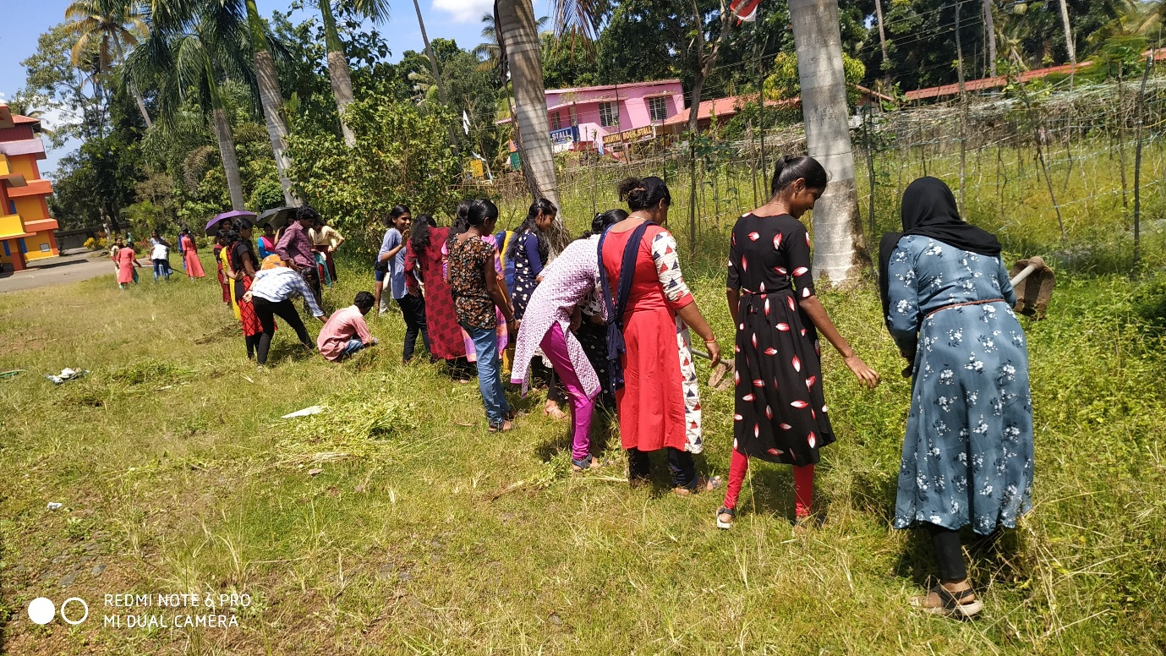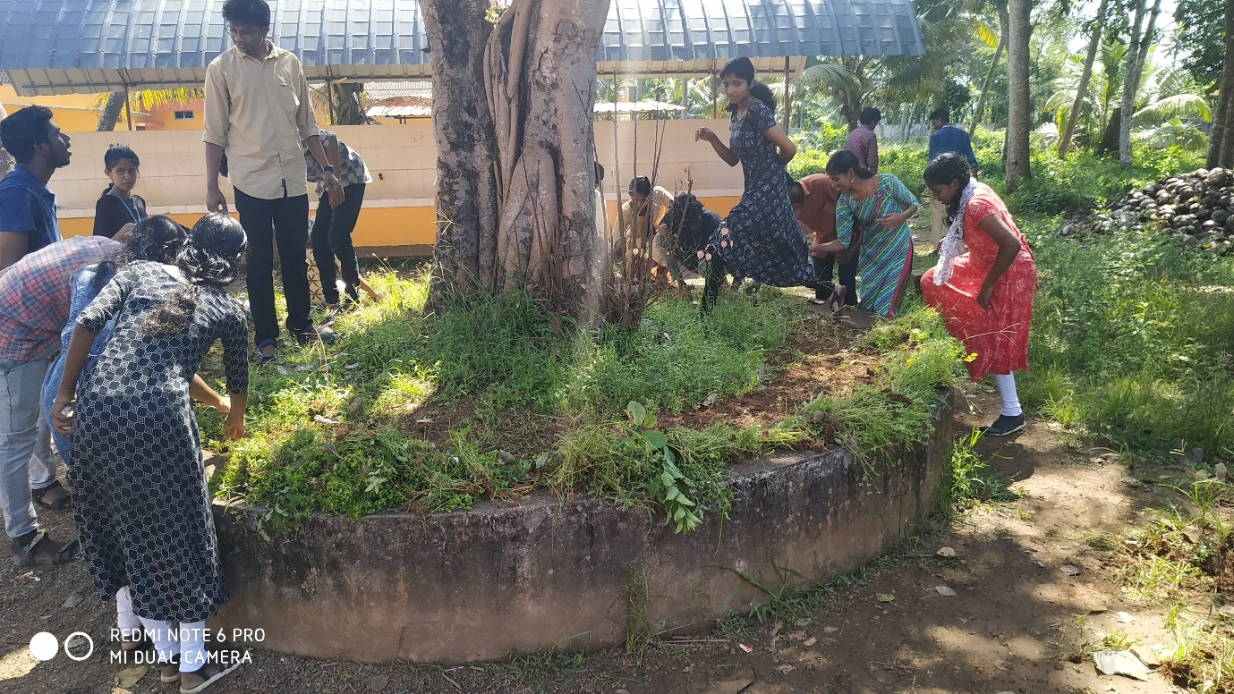

HIV/ AIDS Awareness Programme
An AIDS awareness programme was organized by NCC in collaboration with Primary Health Centre Thalayazham on 2nd December 2019 at the Seminar Hall, St. Xavier’s College Vaikom. A.C Prasad Health Inspector, and Praveen P. Raj, Psychiatric Counsellor, PHC Thalayazham took the awareness sessions and Dr. Rajumon T. Mavunkal, Lt. Roy Mathew, Hav. Yashpal Sigh from 21 (K) Bn NCC Ernakulam, Ms. Vineetha Vijayan Juniorr Health Inspector, also spoke on the occasion. 84 NCC cadets participated in the event

