**FINAL REPORT**

**On**

**MINOR RESEARCH PROJECT ENTITLED**

“**EFFECT OF MULTIWALLED CARBON NANOTUBES ON NATURAL RUBBER/POLYPROPYLENE BLEND SYSTEM**

**(FROM 1-04-2015 TO 1-04-2017)**

**SUBMITTED**

**TO**

**UNIVERSITY GRANTS COMMISSION**

**SOUTH WESTERN REGIONAL OFFICE**

**BANGALORE**

**BY**

**SHARIKA T.**

**DEPARTMENT OF CHEMISTRY**

**ST.XAVIER’S COLLEGE VAIKOM**

**KOTTAYAM, KERALA-686607**

**1.Introduction**

The technology of blending polymers has been one of the major areas of research and development in polymer science in the past three decades.

Polymer blends are the mixtures of two or more polymers or copolymers and are considered as the physical mixtures of structurally different polymers that interact through secondary forces with no covalent bonding.

[1]. All new materials attract interest on the basis of their property-processing-cost performance.[2] The utility of polymer blends in commerce has resulted from the noted emphasis and understanding of polymer blend technology. It has been well-recognized that polymer blends offer a key option in solving emerging application requirements.

Nowadays polymer blending has gained considerable importance because blends usually give rise to certain properties that cannot be attained from individual components.[3] The advantages of polymer blends versus developing new polymeric structures have been well-documented. It is possible to bring the properties of the individual components to a single material by blending different polymers. This strategy is usually cheaper and less time-consuming than the development of new monomers and/or new polymerization routes, as the basis for entirely new polymeric materials. Blending of polymers are usually takes place in processing machines, such as twin-screw extruders, which are considered standard industrial equipment. So the financial risk inherent to the development of new materials is limited in case of polymer blends. An additional advantage of polymer blends is that a wide range of material properties is within reach by merely changing the blend composition. The ability to combine existing polymers into new compositions with commercializable properties offers the advantage of reduced research and development expense compared to the development of new monomers and polymers to yield a similar property profile. In the rapidly emerging technology landscape, polymer blend technology can quickly respond to developing needs, much faster than the time consuming R&D involved with new monomer/polymer development.

The following material-related benefi ts can be cited by blending process

(i) Providing materials with full set of desired properties at the lowest price. (ii) Extending the engineering resins’ performance. (iii) Improving specific properties, like impact strength or solvent resistance. (iv) Offering the means for industrial and/or municipal plastics waste recycling. Blending also benefi ts the manufacturer by offering: (i) Improved processability, product uniformity, and scrap reduction. (ii) Quick formulation changes. (iii) Plant flexibility and high productivity. (iv) Reduction of the number of grades that need to be manufactured and stored. (v) Inherent recyclability, etc.[4]

A recent trend in research of polymer blends is the study of the influence of nanofillers on various properties of immiscible blends. Nanofiller can play the role of both structural reinforcement and compatibilizer for several types of immiscible polymer blends. Polymer nanocomposites (PNCs) are defined as a combination of a continuous polymer matrix with dispersed particles which have at least one characteristic dimension in the nanometre length scale. The continuous polymer matrix could be either a single phase or multi-component polymer. Because of this nanometer size characteristic, nanocomposites possess superior properties than the conventional composites due to maximizing the interfacial adhesion. The recent resurgence of interest in polymer nanocomposites has emerged for several reasons. First, properties of nanofillers are entirely different from the bulk properties of the same material. Hence it can provide polymer nancomposites with unique properties. Second, since the nano scale fillers are small defects, they can prevent early failure, leading to nanocomposites with enhanced ductility and toughness. Third, due to the large surface area of the fillers, the uniform distribution of any isotropic or anisotropic nanofillers in a multicomponent materials like polymers give ultra large interfacial area between the constituents . In addition the distance between nano elements will approach molecular dimensions at low loading. Such properties can imparts unique attributes to the composite materials. Properties which have been shown to improve substantially are mechanical properties (e.g., strength, elastic modulus and dimensional stability),electrical properties, thermo mechanical properties and permeability (e.g., gases, water and hydrocarbons). Others are thermal stability and heat distortion temperature, smoke emissions, chemical resistance, surface appearance, physical weight and flame retardancy.

Carbon nanotubes (CNTs) are a new class of material with a range of potential applications.

[5] In recent years the use of CNTs in polymer materials has received a great deal of attention from both scientific and industrial groups.[6] Because of its unique atomic structure with a very high aspect ratio, a low density, a variety of polymer nucleation behaviors, and extraordinary mechanical properties, CNTs are considered as an excellent reinforcing fibers in nanocomposites .[7] It has been reported that the addition of CNTs in different polymer matrices has effectively improved the matrix properties. Researchs in the fabrication of nanotube composite materials[8] has a particular interest due to the exceptional high tensile strength and stiffnes achieved by the Polymeric materials with the addition of MWCNTs.

Among the most versatile polymer matrices, polyolefins such as polypropylene (PP) are the most widely used thermoplastics because of their well-balanced physical and mechanical properties and their easy processability at a relatively low cost that makes them a versatile material.[9] Polypropylene (PP) has a remarkable combination of physical properties and good processability. However, the application of PP is limited by its brittleness and low stiffness at low temperatures. Elastomers can be used to improve the toughness, but they reduce the modulus of the polymer. These blends, commonly called thermoplastic elastomer polyolefins (TPOs), are a class of materials that combine the good processing characteristics of thermoplastics at elevated temperatures with the physical properties of conventional elastomers at service temperatures, playing an increasingly important role in the polymer industry.[10]

The properties of polymer blend nanocomposites depends upon its morphology and is determined by the localisation of nanofillers in polymer blends. It was reported prior that multiwalled carbon nanotube (MWCNT) could tune the blend morphology in immiscible polymer blends.[11],[12] Understanding and controlling of the localisation of these conductive nanofillers in polymer blends are the keys toward making new tailor-made materials.[13],[14] In immiscible blends with co-continuous morphology, the selective localisation of CNTs in one phase or partially at the interface could help to achieve a low percolation threshold due to the phenomenon called ‘double percolation’. Most researchers reported that CNTs filled immiscible polymer blends with cocontinuous morphology usually exhibit excellent electrical conductivity due to the selective distribution of CNTs in one phase even if the content of CNTs is very low.[15] Other researches found that the addition of CNTs has profound influence on mechanical property of the material as well.[16] Besides, it is also possible to alter the morphology of immiscible polymer blends by adding CNTs.[17]

The blends of polypropylene and natural rubber (PP/NR) is an industrially important blend, especially in natural rubber producing countries where this thermoplastic elastomer (TPE) rubber can be used for myriad applications. The incorporation of nanofillers in PP/NR blends was previously reported by Bendjaouahdou and Bensaad.[18] They studied the role of organically modified montmorillonite (OMMT) in compatibilizing PP/NR blend. To the best of our knowledge the effect of MWCNTs on the properties of PP/NR blends has not received much attention.

In this study, PP/NR blends and blends filled with MWCNT (with different MWCNT loading) were prepared using melt blending technique. We have developed PP/NR blend nanocomposites with two distinct morphologies i.e matrix droplet and co-continuous by varying the blend composition. By considering the absence of significant literature on MWCNT filled PP/NR blends and their importance in various applications the current study focusses on the morphology change of PP/NR blends with the incorporation of CNTs, and its effect on the rheological, mechanical and electrical properties of the prepared blend nanocomposites. The thermodynamically feasible location of MWCNT in PP/NR blend at processing temperature will be predicted quantitatively by considering this established cation-ℿ interaction between the phospholipids in the NR and MWCNT and will be correlated with the rheological and morphological findings to suggest possible mechanism of percolation in various MWCNT filled blends. The observed mechanical and electrical properties of the blend nanocomposites are attributed to the morphological and microstructural changes associated with MWCNT addition in the PP/NR blends.

**2. Experimental**

**2.1 Materials**

Isotactic polypropylene (PP) (grade H350 FG, melt flow index = 38 g/10min) used in the present study was supplied by Reliance India Ltd. Natural rubber (ISNR- grade-5, Mn= 7.79xl05) used in the study was procured from Rubber Research Institute of India, Kottayam. The Multi walled carbon nanotubes (MWCNT) was supplied by Nanoshel, Punjab.

**2.2 Natural Rubber(NR)/Polypropylene(PP) Blend Preparation**

Natural Rubber and polypropylene were blended. Mixing was done in a hakae rheocorder at 180 0C at a rotor speed of 60rpm. The total mixing time was 10 minutes. In all the mixing the polypropylene was added first and allowed to melt for 2 minutes and the rubber was added and the mixing was continued for another 8 minutes. The blend compositions include 90/10,80/20,70/30,60/40,50/50,40/60 PP/NR blends.

**2.3 Preparation of PP/NR/MWCNT Composites**

MWCNTs filled PP/NR blends were prepared by melt mixing method in a Brabender Plasticorder at 180 0C with a rotor speed of 60rpm. The total mixing time was 10 minutes. In all the mixing the polypropylene was added first and allowed to melt for 2 minutes, then rubber was added and after one minute Multiwalled Carbon Nanotube is added. The mixing was continued for another 7 minutes. Nanocomnposites are prepared by adding 1, 3, 5 & 7 wt% of MWCNTs into various PP/NR blend composition (80/20, 50/50,20/80) during melt mixing. The prepared composites are moulded as 2mm thick sheets by compression moulding at 180 °C for 10 minutes.

**2.4. Characterization Techniques**

**Scanning Electron Microscopy (SEM)**

Morphological studies were carried out using Scanning Electron Microscope (SEM), JEOL (model-JSM- 6390). The prepared blends and composites were cryogenically fractured in liquid nitrogen to avoid any possibility of phase deformation during the fracture and the NR phase was extracted in toluene. After etching, the samples were coated with platinum using sputter coater before scanning.

**Transmission Electron Micrscopy (TEM)**

The micrographs of the samples were taken using Jeol JEM-2100 transmission electron microscope with an accelerating voltage of 200 keV. Ultrathin sections of bulk specimens (about 100 nm in thickness) were obtained bycryocutting with an ultramicrotome fitted with a diamond knife.

**Rheological Analysis**

Dynamic frequency sweep rheological analysis were carried out in Stress Controlled rheometer DHR3 (Discovery Hybrid Rheometer 3) from TA instruments. The measurements were performed in 25 mm parallel plates geometry at 180 °C. The frequency varied from 0.1 to 100 rad/s.

**Mechanical Properties**

Tensile properties of the samples were measured using universal testing machine (Tinius Olsen) with a cross-head rate at 500mm/min according to ASTM D 412-98 at a room temperature (25 ± 2 °C). Five dumbbell shaped samples of each system were used to determine the young’s modulus, tensile strength and elongation at break. Tensile modulus was taken as the slope of the initial linear region of the stress-strain curve.

**Electrical Properties**

The DC electrical conductivity of nanocomposites was measured using two different arrangements. For nanocomposites with electrical conductivity <10-6 s/cm, a setup consisting of the Keithley 6517B electrometer (Keithley, Ohio, USA) and a Keithley 8009 test fixture was used. For higher conductive nanocomposites, a Keithley 2400 Source meter and four probe setup were used to measure the conductivity.AC conductivity is obtained from impedence analyzer.

**3.Results and Discussion**

**3.1Morphological Stuides of PP/NR blends and Nanocomposites**

Scanning Electron Microscopy (SEM) has been successfully used as a valuable tool in studying the phase morphology of blends. In using the SEM, the sample preparation is quite simple unlike in other microscope and it presents a physical picture of the phase structure of the blend under investigation. Morphology of an elastomer blend explains how the rubber phase is dispersed as domain in another continuous rubber matrix. Since the size distribution changes with compositions, the dispersed phase dimensions increases with increasing concentration of the rubber phase due to coalescences.

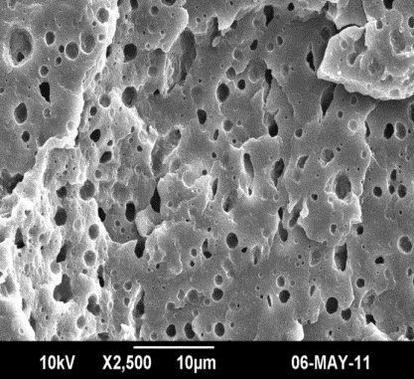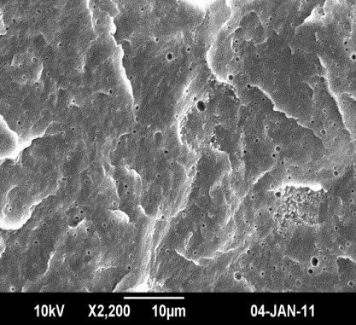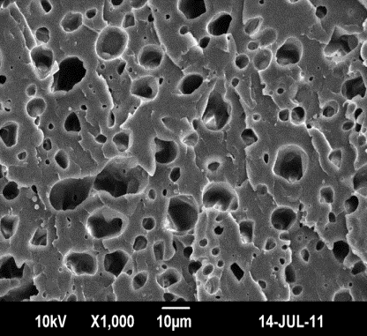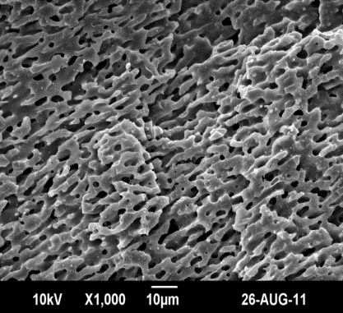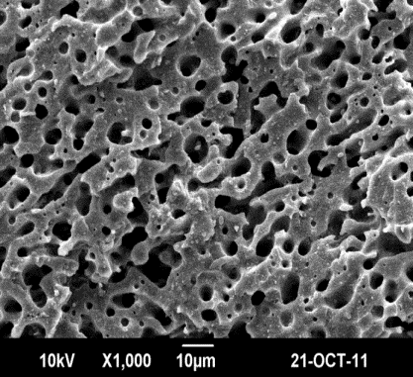

**a)**

**b)**

**c)**

**d)**

**e)**

***Fig 1. SEM images of a) 90/10 b)80/20 c)70/30 d)60/40 e)50/50 PP/NR blends***

Fig 1 (a) shows the SEM result of 90PP/10NR blend. It reveals a two-phase morphology in which NR is dispersed in PP. NR domains are uniformly distributed throughout the matrix. The size of the dispersed phase is 0.4118 micrometers. Fig 1(b) shows the SEM result of 80 PP/20NR blend . It also shows dispersed phase morphology. The size of the dispersed phase is 0.9650 micrometers. Fig1 (c) shows the SEM picture of 70PP/30NR blend . The size of the dispersed phase is 1.7111 . Fig 1(d) reveals the SEM picture of 60PP/40NR . It shows a co-continuous phase morphology ie NR and PP phases are continuous throughout the matrix. .

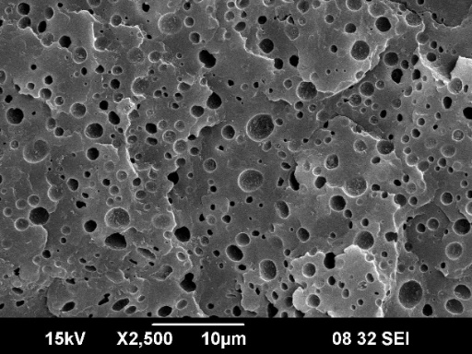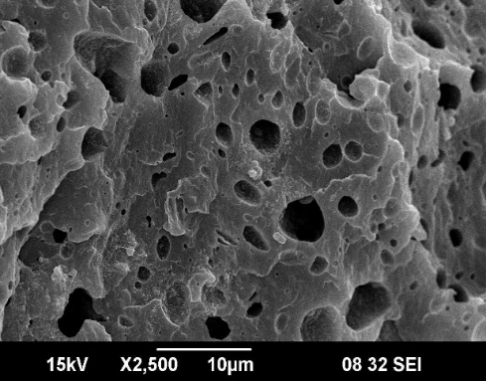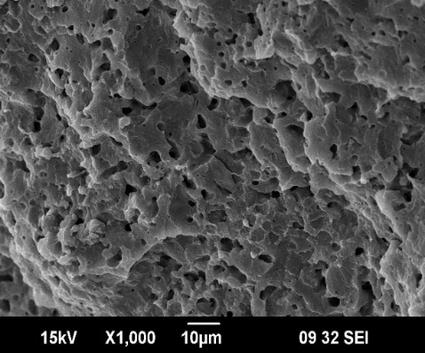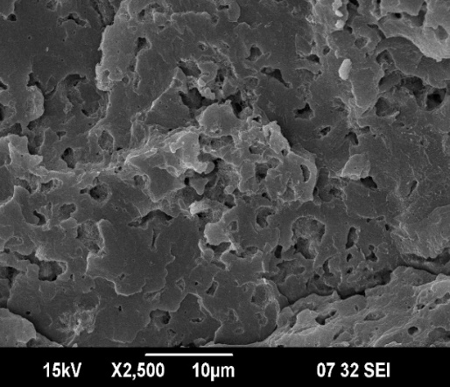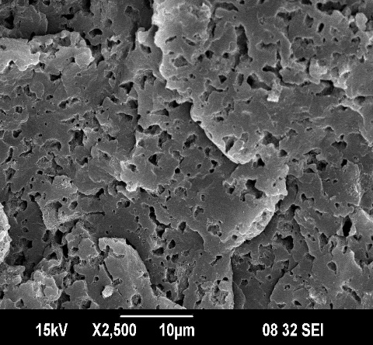

**a)80/20 PP/NR**

**b) 80/20 PP/NR**

**+1 wt% MWCNT**

**c) 80/20 PP/NR**

**+3 wt% MWCNT**

**d) 80/20 PP/NR**

**+5 wt% MWCNT**

**e) 80/20 PP/NR**

**+7 wt% MWCNT**

**Figure 2.** SEM images of 80/20 PP/NR/MWCNT composites

Polymer blending is an efficient method for developing materials with superior properties than the blend components, but immiscibility either chemical incompatibility or lack of specific interaction usually leads to heterogeneous morphologies. The specific interaction between polymer constituents and the resulting morphology of blend system determine the final performance of the material.

[19] So, monitoring the final morphology during blending is the deciding factor of the final properties of the blend.[20] Factors such as the interfacial tension, viscosity ratio, blend ratio, elasticity, processing conditions, etc. determine the morphology of polymer blend. Depending on the balance of these forces, different morphologies such as dispersed and co-continuous types can be achieved. On adding nanoparticles like MWCNT to this blend system a prominent morphological transformations with particle content might be expected. The selectively localized MWCNTs in one of the blend component increases the viscosity of the phase and will changes the viscosity ratio between polymer phases. Also the elasticity of the system get enhanced by increasing MWCNT content.

To deeply investigate the effect of MWCNT loading on the phase morphology of PP/NR blends, fractured surface of all samples were analyzed by SEM and are shown in Figure 2. It should be noted that in all the cases, SEM morphology was obtained after selectively etching the NR phase by toluene (for 72 h) to improve the contrast between the phases

Fig 2(a) shows that neat blend has a matrix-droplet type morphology with NR as the dispersed phase and PP as the matrix. Fig 2(b) indicates that at 1 wt% MWCNT loading NR droplets are get elongated, and became irregular in shape. The presence of MWCNTs in NR phase increases the viscosity of NR droplets, this result the breakup and reshaping of deformed NR droplets to spherical shape much harder. Moreover, MWCNTs often curl and reside inside the droplet, can still induce a domain bridging effect as their length is often larger than the domain size . This self networking capability of MWCNTs can further slowdown the relaxation time of NR droplets. All these effects leads to the formation of big irregularly shaped NR droplets in (80/20/1wt% MWCNT) blend. Several factors such as filler localization,[21] filler functionalization[22], filler geometry [23] and particle self-networking in the host polymer[24] affect the size and shape of droplets by the addition of nanofillers in blend nanocomposites.

Fig 2(c-e) shows that, as increasing the MWCNT content the NR droplets were highly deformed to spheroidal and elongated structures. At higher filler loading the amount of MWCNT is high enough to hinder the relaxation of NR droplets. Thus, as MWCNT content increases, the relaxation time of NR droplets get increased and high shear forces are needed to break up the MWCNT filled NR phase. Hence, at the same mixing conditions, with addition of MWCNT slowdown of breakup mechanism happens and NR droplets get elongated.[25] There are many reports regarding this type of morphological changes with MWCNT loading in various blend system.[26],[27],[28]

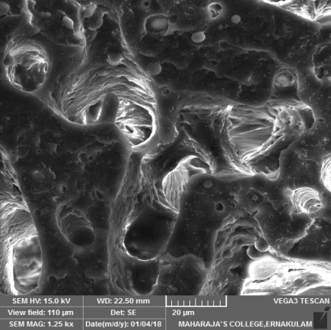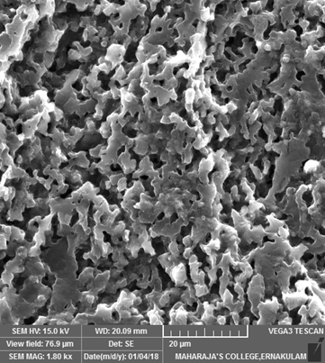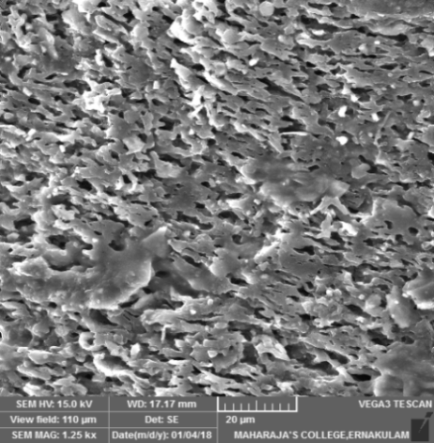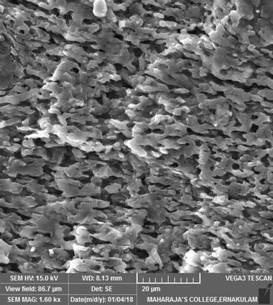

**a)50/50 PP/NR**

**b) 50/50 PP/NR**

**+1 wt% MWCNT**

**C) 50/50 PP/NR**

**+3 wt% MWCNT**

**d) 50/50 PP/NR**

**+5 wt% MWCNT**

**e) 50/50 PP/NR**

**7 wt% MWCNT**

***Figure 3: SEM images of 50 PP/50NR blends with different MWCNT loading***

Figure 3 shows the SEM images of 50PP/50NR blends and its composites. It is observed from Figure.3(a) that the neat blend shows a coarse co-continuous type of morphology. Figure 3(b-e) indicates that after addition of MWNTs, there is no significant changes in the co-continuous structure. However, there is decreases in the width of NR and PP continuous phase with the addition of MWCNT is observed. Here, continuous NR phase provides sufficient space for the uniform dispersion of CNTs with less chance of interfacial bridging between NR and PP phase. According to Göldel et al such [debundled](https://glosbe.com/en/en/debundling)  MWCNTs comes under high aspect ratio nano objects which have fast interfacial transfer and low interfacial stability during melt mixing process of two immiscible blends.

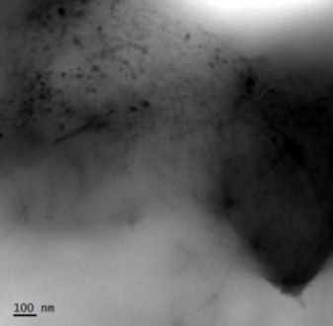

**c)**

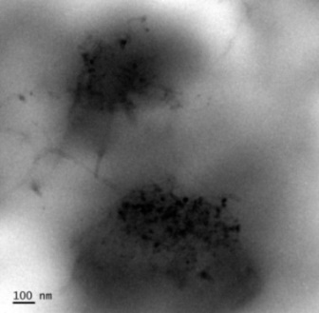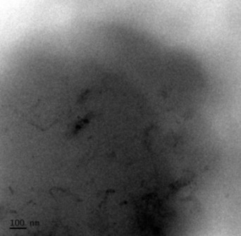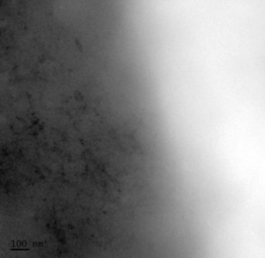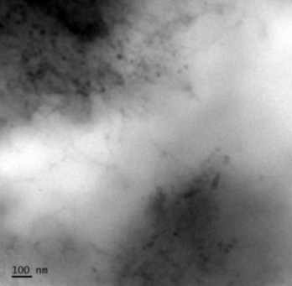

PP

NR

PP

NR

PP

**NR**

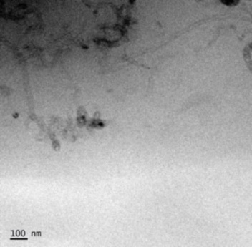

NR

PP

**a)**

**b)**

**f)**

NR

PP

PP

NR

**d)**

**e)**

CNT

CNT

***Fig 4. TEM images of a) 80PP/20NR/1wt%MWCNT b) 80PP/20NR/3wt% MWCNT c) 80PP/20NR/5wt%MWCNT d) 50PP/50NR/1wt%MWCNT e) 50PP/50NR/3wt%MWCNT f)50PP/50NR/5wt%MWCNT blends***

Figure 4(a-c) represents the TEM micrographs of 80PP/20NR blends filled with 1,3, & 5wt% MWCNTs. As seen in Figure. 4a and b, the 80 PP/20NR/MWCNT composites have a matrix droplet morphology where NR phase distributed uniformly as distorted droplets in PP matrix. It is observed that most of the MWCNTs are preferentially distributed in droplets. Thus the dark regions of these figures are the MWCNTs rich NR domains and the bright region represents the PP phase. In PP/NR blend, the MWCNTs shows high affinity towards NR phase and is predicted thermodynamically. At 1wt% CNT loading most of the MWCNTs are crowded at the NR phase. But at higher filler loading the effective concentration of MWCNTs in a specific phase increases and this leads to the hanging of MWCNTs from the NR droplets to the continuous PP phase. More interestingly, the nanotubes are found to bridge the NR domains as evidenced from the Figure.4b. Thus the extended MWCNTs would connect each other to form the conductive path through the entire material and is responsible for the good electrical properties of our composites, which will be discussed later. Figure 4(d-f) shows that 50 PP/50 NR blend filled with MWCNTs has a co-continuous morphology, where most of the MWCNTs are preferentially located at the NR phase. Here also it is observed that at higher filler loading some MWCNTs are get extended into the PP phase.



a

***Fig 5. TEM image of 80NR/20PP blend with 3 wt% MWCNT***

Fig. 5 shows that the 80 NR/20PP blend with 3 wt% MWCNT has matrix droplet morphology where the droplets of PP dispersed in NR matrix. The PP droplets in 20/80 PP/NR blend matrix are smaller and denser than NR droplets in 80PP/20 NR blend matrix. In 80PP/20 NR blend , the selective localisation of MWCNT in NR phase hinders them from break-up to form smaller particles. In 20/80 PP/NR blend, the MWCNT connects the neighbouring PP droplets as bridges. This bridging MWCNT mainly oriented perpendicular to the blend interface. This implies that some of the MWCNTs were found located with one part in the NR phase and the other in the PP phase. Here, the viscosity ratio of blend component play an important role in bridging phenomenon.42

**3.2. Rheological Studies**

**3.2.1Rheological behaviour of PP/MWCNT composites**

The influence of the MWCNTs on the linear viscoelastic behaviour of Polypropylene (PP) was studied. Melt rheological analysis of PP/MWCNT nanocomposites were carried out at 180 °C. The variation in storage modulus (G΄) and loss modulus with frequency is given in Fig.6a and 6brespectively.

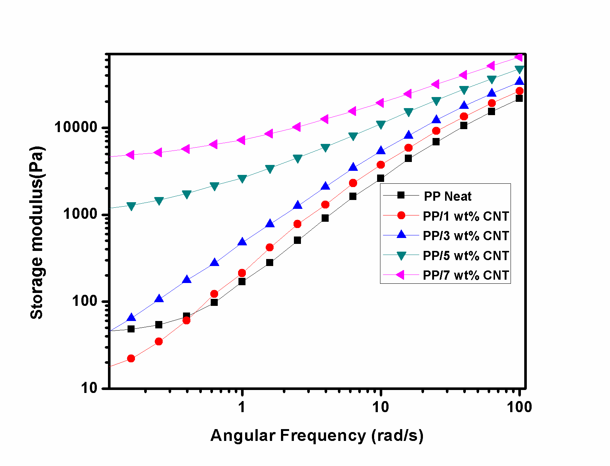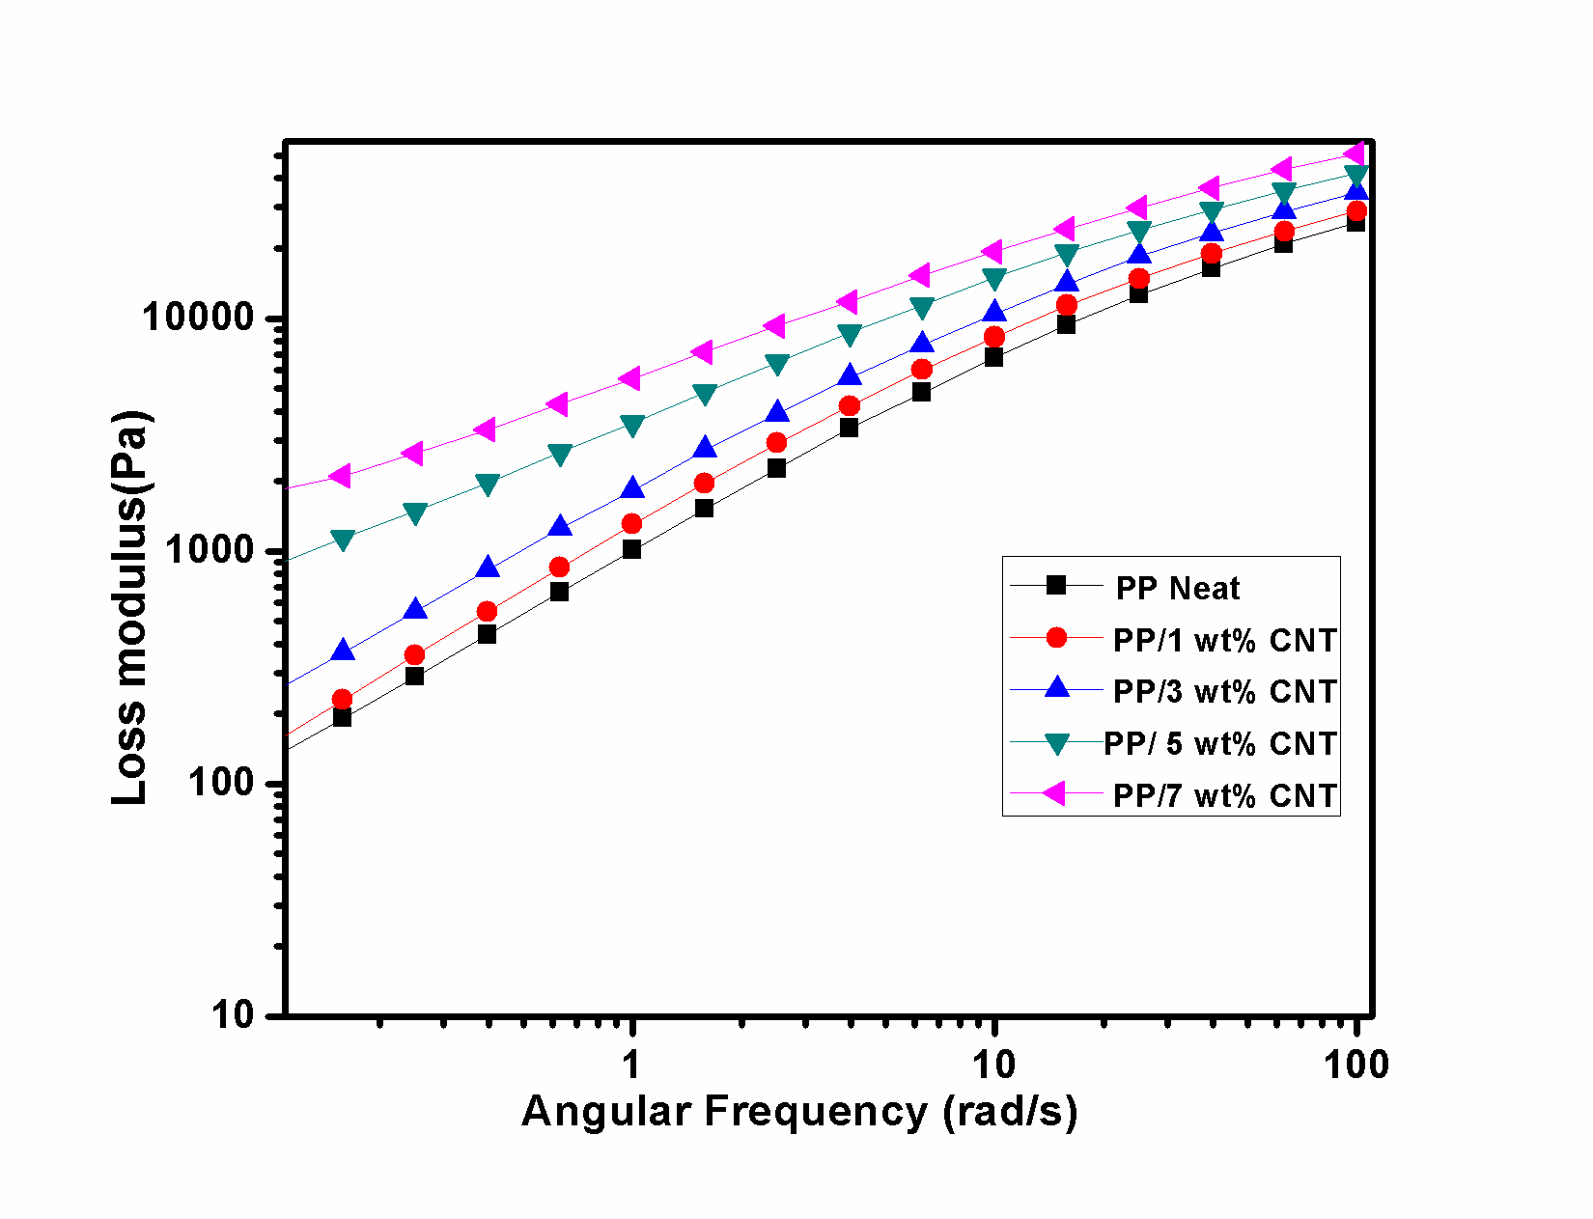

a)

b)

a

***Fig 6. (a) Storage modulus Vs frequency and (b) Loss Modulus Vs frequency for PP/MWCNT nanocomposites.***

The effect of dispersion of MWCNT on the rheological behaviour of PP/MWCNT melt can be used to determine dispersion state of MWCNT. The formation of a ‘gel-like’ structure by the filler above a critical concentration results in a ‘sol-gel’ transition in the nanocomposites and is termed as rheological percolation threshold. As the MWCNT content increases in the melt, the tube-tube interactions dominate over polymer-particle interactions and eventually lead to percolation and formation of interconnected network of MWCNT. The percolation concentration of filler is often quantified by a plateau in the elastic modulii (G΄) at low frequency region.[29],[30] This non-terminal low frequency behaviour can be attributed to a nanotube network, which restricts the long-range motion of PP chains. Below percolation concentration, the PP chains are still fully relaxed and exhibit typical homopolymer-like terminal behaviour. It is found that the rheological percolation threshold observed for the PP/MWCNT nanocomposites is above 3 wt% of MWCNT. Loss modulus of PP/CNT composites also follows the same trend as that of storage modulus.

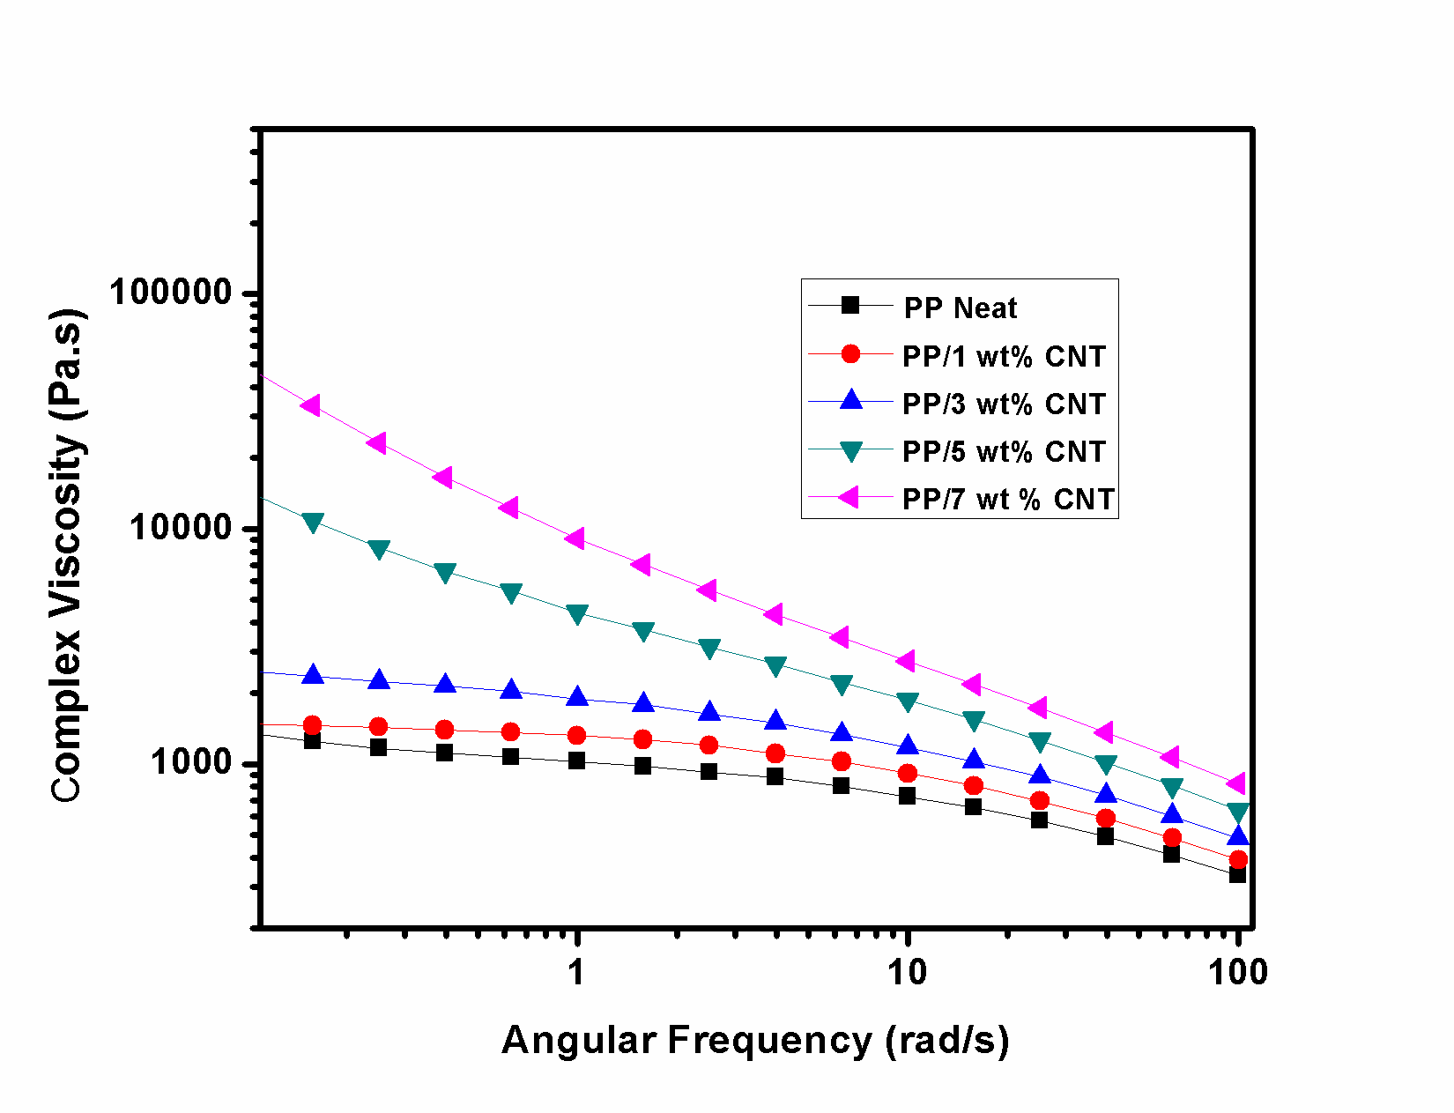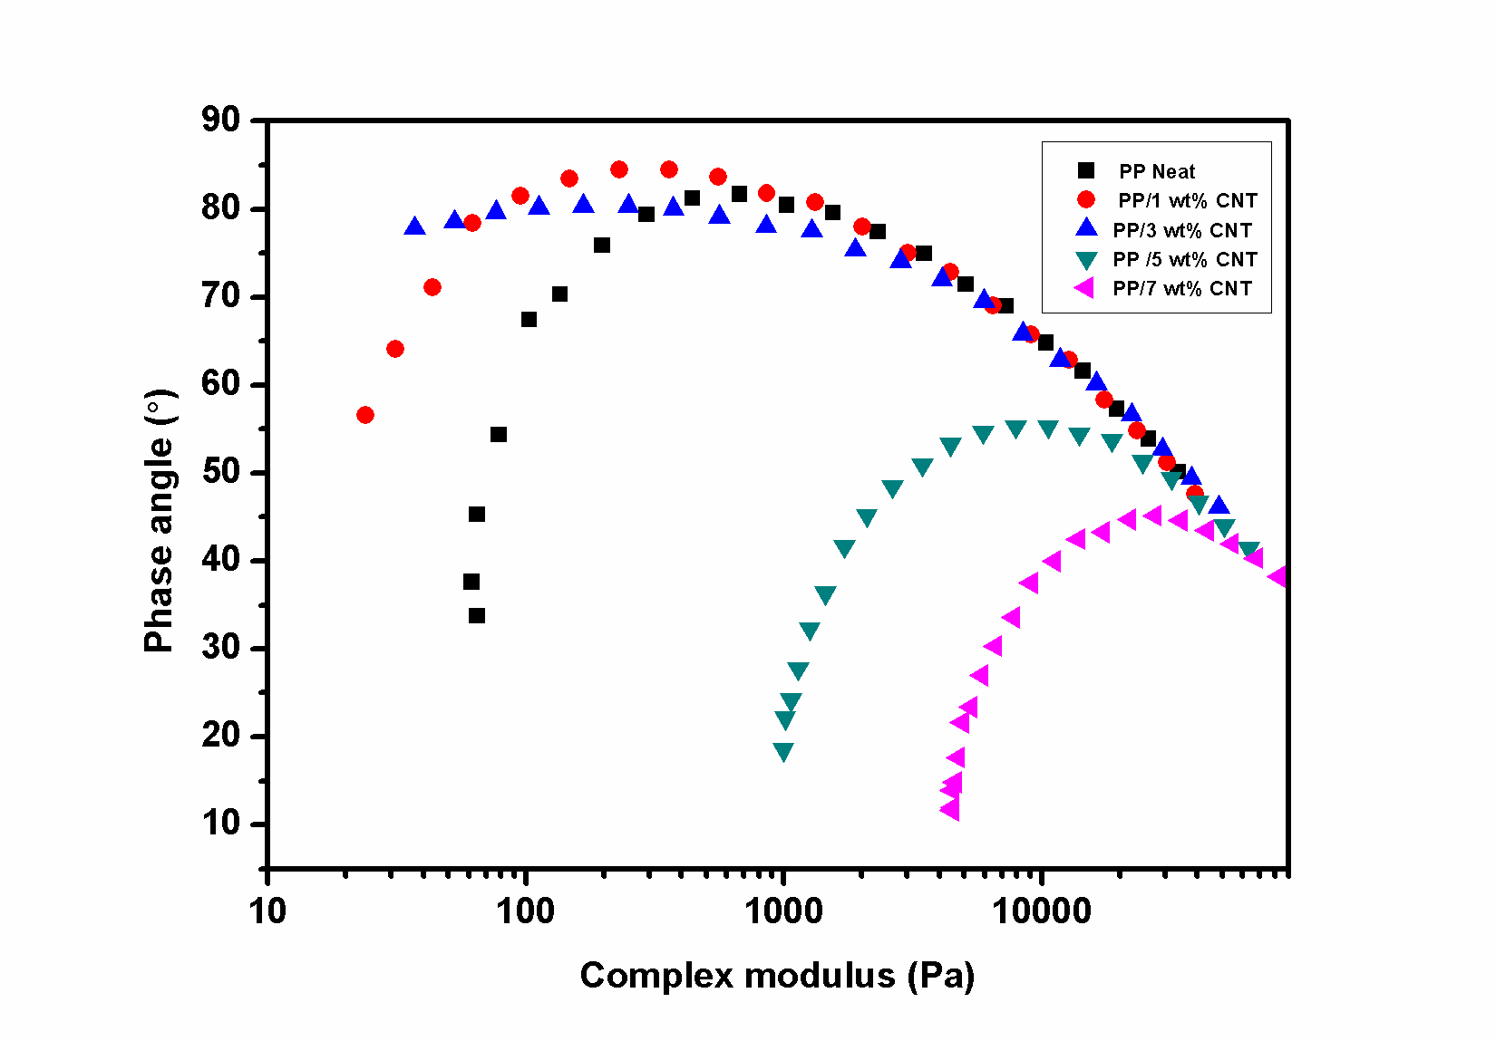

a)

b)

***Fig7.a) Complex viscosity vs frequency b) Van- Gurp Palmen Plot for PP/MWCNT composites***

The neat PP melt shows frequency independent flow (i.e., Newtonian) behaviour at low frequency (Fig.7a). PP/MWCNT melt having 1 and 3 wt% MWCNT also shows similar flow behaviour as that of neat PP, with a Newtonian plateau at low frequency. However, strong shear thinning behaviour is observed for PP nanocomposites with MWCNT content above 3 wt%. The viscosity increase with increase in MWCNTs is most pronounced at low frequency and the effect weakens with increasing frequencies due to shear thinning. At low frequency, above the percolation threshold, the nanocomposite melt retains nanotube network structure and the small periodical deformation imposed is too weak to induce significant nanotube orientation. At higher frequency the network structure get destructed and oriented along with the flow. While considering the processability of these nanocomposites during extrusion and injection moulding processes, it is significant to have knowledge on the steady shear viscosity (). The applicability of Cox-Merz rule [31] ( for ω=), for predicting the steady shear viscosity data outside the normal measurement range for polymer nanocomposites melts were tested by many researchers. It was reported that the Cox-Merz rule is invalid (i.e., the steady state shear and dynamic viscosities at comparable shear rates/frequencies does not quantitatively agree for many polymer nanocomposites melts and in specific polymer/CNT nanocomposite melts and the deviation is more pronounced above percolation threshold.[32].The violation of the Cox-Merz rule for these nanocomposites (while being obeyed for the polymer itself) suggests a breakdown of the network superstructure when large displacements are imposed on them during steady shear flow.[33]



In order to confirm the percolation threshold, the van Gurp-Palmen plots were used. In van Gurp-Palmen plot, the phase angle is plotted against the complex modulus. It was used to study the elastic and/or viscous dominance. The van Gurp-Palmen plot for PP/MWCNT nanocomposites are given in Fig.7b. This plot shows the structural changes in PP/MWCNT nanocomposites more precisely and is more sensitive to the liquid-to-solid transition. Pan et al.[34] used van Gurp- Palmen plot for studying percolation and gel-like behaviour in PP/MWCNT composites. A significant change in the phase angle occurred at 5 wt% and below this concentration of MWCNT the curves approach a phase angle near 90 °C indicates dominating viscous flow behaviour. The transition is visible at the same composition as in the plots of storage modulus and complex viscosity with frequency (Fig. 6a and 6b).

A transformation of the dispersion state of MWCNT from discrete nanotube rich domains to interconnected network was observed in the blends with 3 wt% to 5 wt% MWCNT

**3.2.2 Rheology of 80PP 20NR/MWCNT composites**

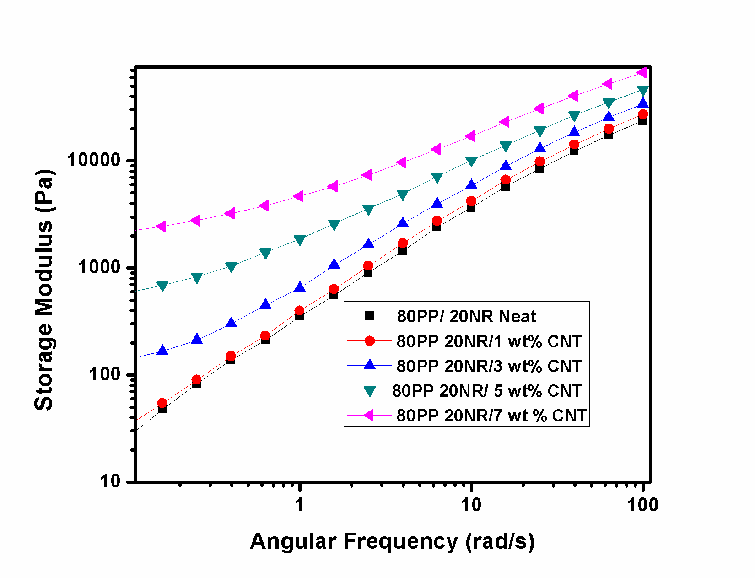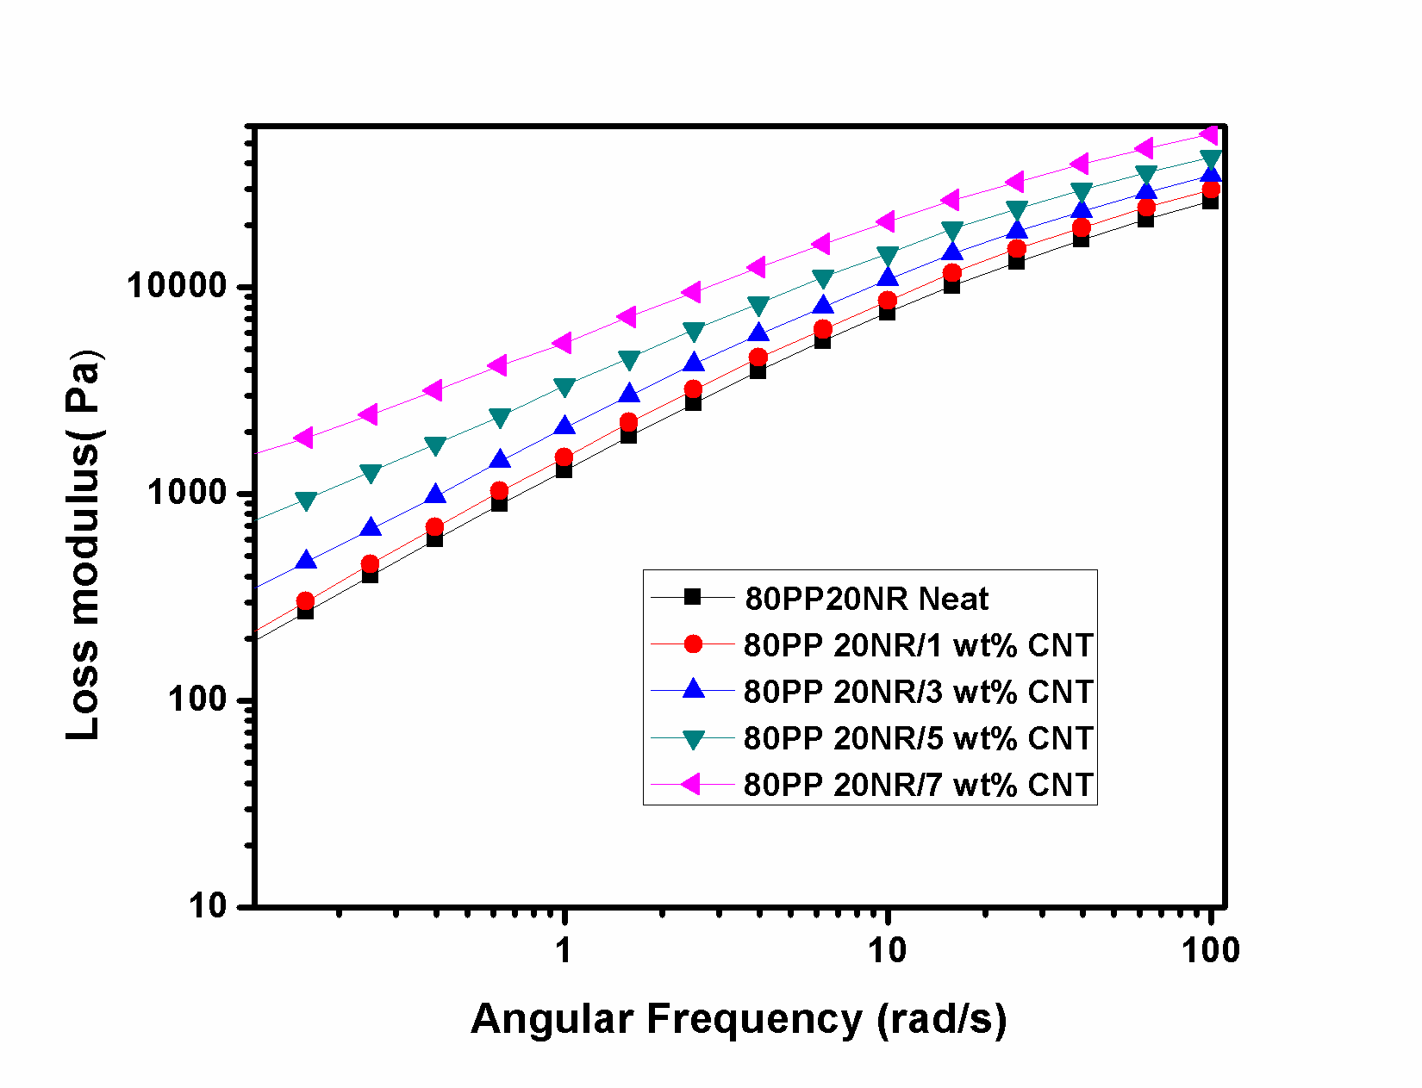

**a)**

**b)**

***Fig 8. The variation in a)storage modulus and b) loss modulus with frequency for 80/20 PP/NR blend with various loading of MWCNT***

The variation in storage modulus and loss modulus with frequency for 80 PP/20 NR blend with various loading of MWCNT at 180 °C is given in Fig8. The fig 8a shows that the storage modulus(G’) of PP/NR nanocomposites were always greater than those of neat PP/NR blends. It can be seen that there was an obvious “plateau” for PP/ NR/MWCNT blends in the low frequency region when CNT concentration was higher than 1.0 wt%,. This frequency independent behaviour at 3 wt% loading of MWCNT is an indication of a transition from liquid-like to solid-like viscoelastic behaviour and is due to the formation of interconnected CNT network within the blend system i.e in 80PP/20NR blends the sol-gel transition takes place at 3wt% MWCNT and is considered as the rheological percolation threshold.

Moreover, the slope of the curves at low frequencies decreased in the presence of higher nanotube loadings. All these results may be attributed to the microstructural changes (created by the nanotube) and appropriate interactions between polymer chains and MWCNTs. As a general observation, the blends with the different compositions of MWNTs showed a frequency independent plateau at lower frequencies along with a pronounced yield stress. At low filer loading the MWCNTs are selectively localized at NR phase and are not sufficient to form a percolated network within the blend system. However at 3 wt% loading, the effective increase in the local concentration of MWCNTs in the NR phase increases and also certain single tubes are get extended into the PP phase. This will facilitates the formation of a percolated CNT network structure within the entire blend system and this effect is increases with increasing the MWCNT content. .

Thus the increase of G’ of PP/NR Blend at high MWCNT content was attributed to the presence of the percolated CNT network which will hinders the macromolecular mobility resulting in confined motion. The Loss modulus (G”) value represents the viscoelastic parameter which gives information about the energy dissipation during the flow of polymers. Both G’ and G” have same trend for all the composites.

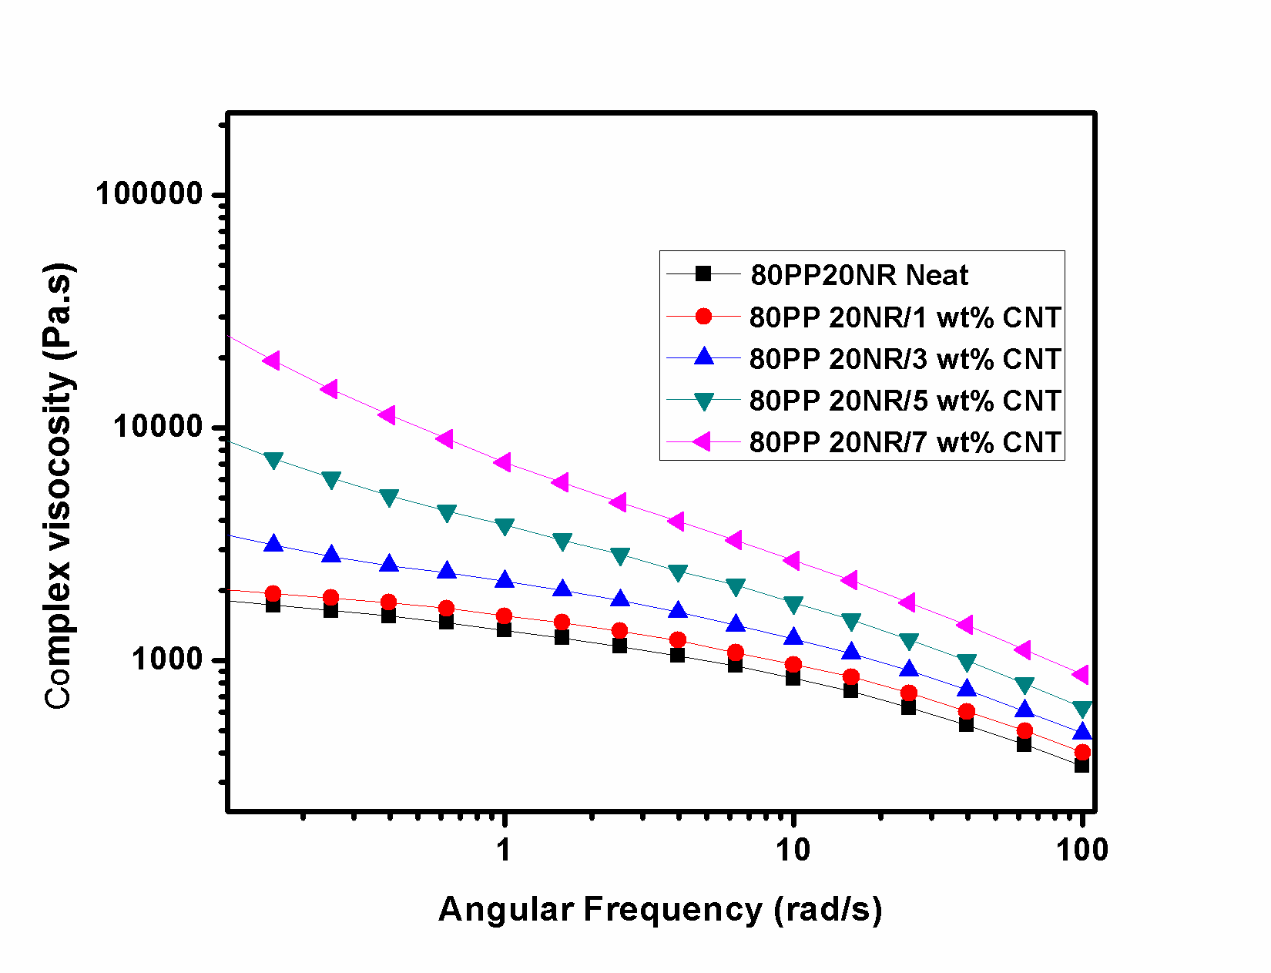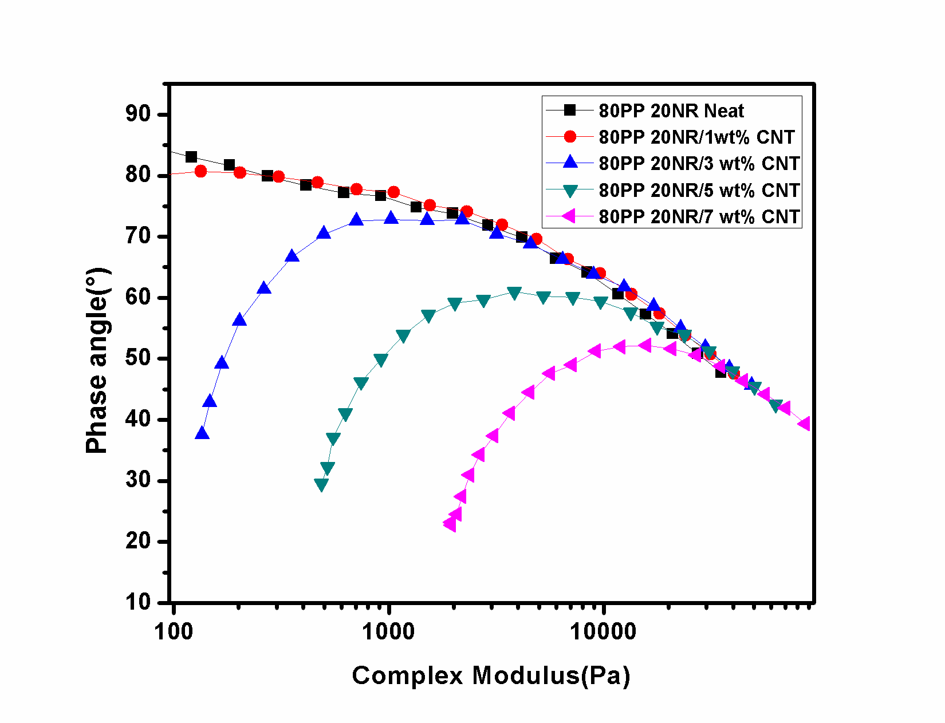

**a)**

**b)**

***Fig 9.a)Complex Viscosity b) Van Gurp Palmen Plot of 80PP/20NR blend with various MWCNT loading.***

The network formation and yield stress are also apparent from the complex viscosity of the blends. Fig. 9a shows the complex viscosity as a function of frequency for 80PP/20NR blend and its composites. Neat blend showed almost a Newtonian type behaviour and only a moderate shear thinning behaviour at lower frequencies. The phenomenon of shear thinning starts to observe above 1 wt% MWCNT in 80/20 PP/NR blend . It is found that on blending with NR, the complex viscosity of PP at low frequency is increased. The complex viscosity of PP/NR immiscible blend at low frequency reflects the contribution of blend component viscosities. The addition of 3 wt% MWNTs resulted in a distinct change in the viscosity, especially at low frequencies, where ample time is available for chain relaxation. The complex viscosity is observed to increase with increasing MWNT concentration, This clearly suggests that the network of MWNTs impedes the macromolecular motion in,a given flow field. It is also well observed that the enhancement is more pronounced at lower frequency region where sufficient time is offered for chain relaxation. The selective localization of MWNTs further resulted in a dense network due to an increase in the effective concentration of the nanotubes in a given phase. This observation clearly indicates that network of MWNTs can constrain the macromolecular motion in a given flow field and MWCNT has significant effect on the microstructure of blends.

According to the curves, the samples filled with higher loadings of MWCNTs showed stronger shear thinning behaviour. At low frequency, above the percolation threshold, the nanocomposite melt retains nanotube network structure and the small periodical deformation imposed is too weak to induce significant nanotube orientation. On the other hand, high shear rates forced nanotube sheets to orient in the flow direction, and hence viscosity decreased.[35]

By adding higher volumes of MWCNTs to the PP/NR blend, the nanotube -polymer interactions and also the number of oriented CNTs in the flow direction increased. Therefore, higher viscosity and stronger shear thinning behaviour could be seen in the presence of higher nanotube content. Similar results have been reported for PP/PA-6/nanoclay nanocomposites.[36], [37]

.The corresponding van Gurp-Palmen plot is presented in Fig.9b. Compared to neat PP for 80/20 PP/NR blend and 80/20 PP/NR + 1 wt% MWCNT nanocomposite, the van Gurp-Palmen curves approach a phase angle below 90°C due to the increased elasticity in the system. For blend nancomposites a significant change in the phase angle occurred at 3 wt% and below this concentration of MWCNT the curves approach a phase angle near 90°C indicates dominating viscous flow behaviour. The transition is visible at the same composition as in the plots of storage modulus and complex viscosity with frequency . It gives an indication that blending could reduce the rheological percolation threshold. The reason for reduced rheological percolation threshold can be explained on the basis of nature of the network which itself depend on the selective dispersion of the MWCNT in the PP/NR blend and blend morphology.

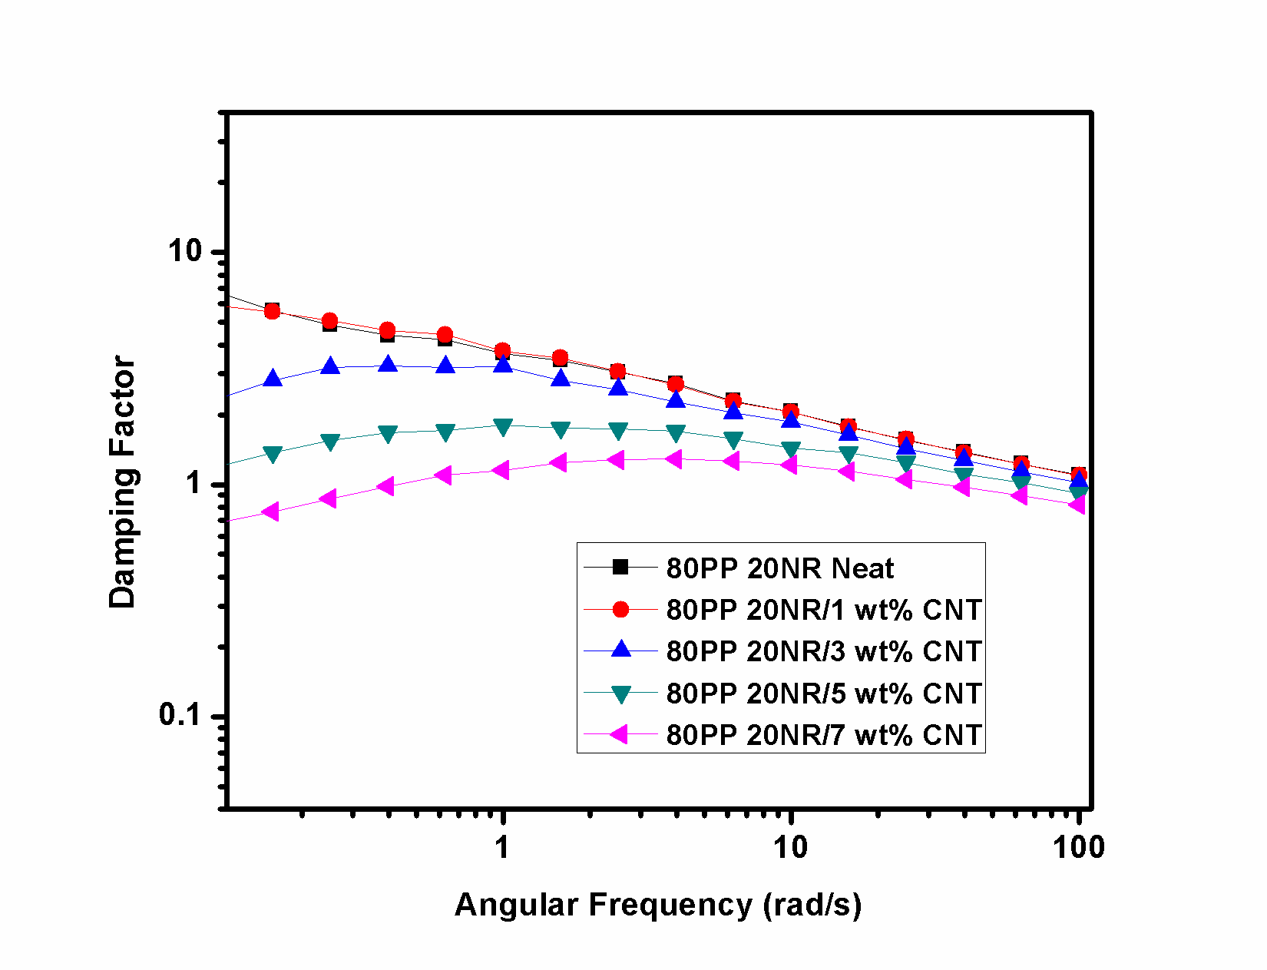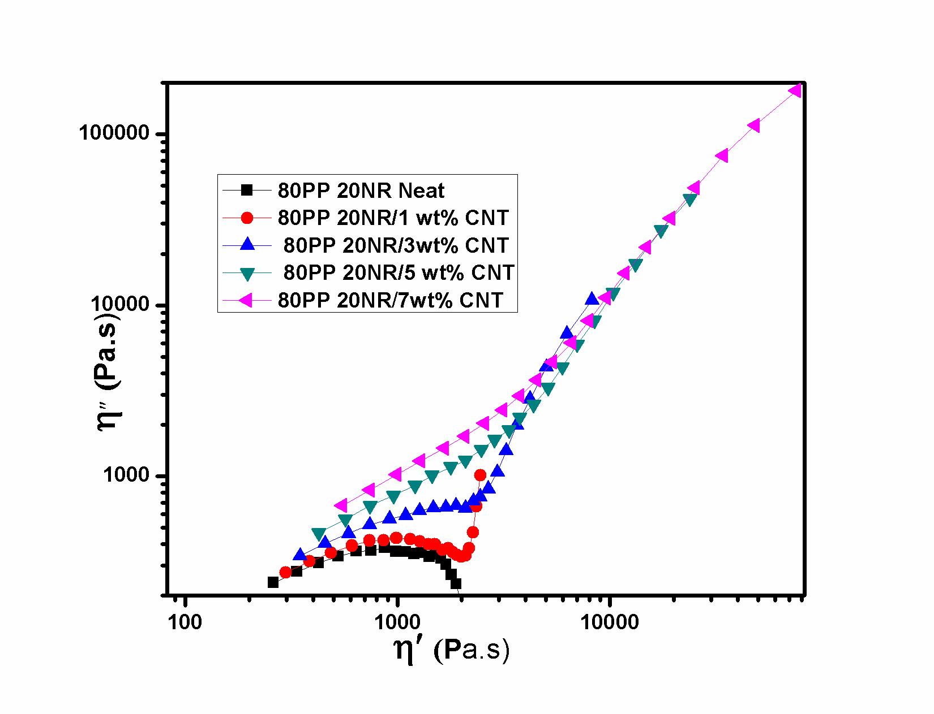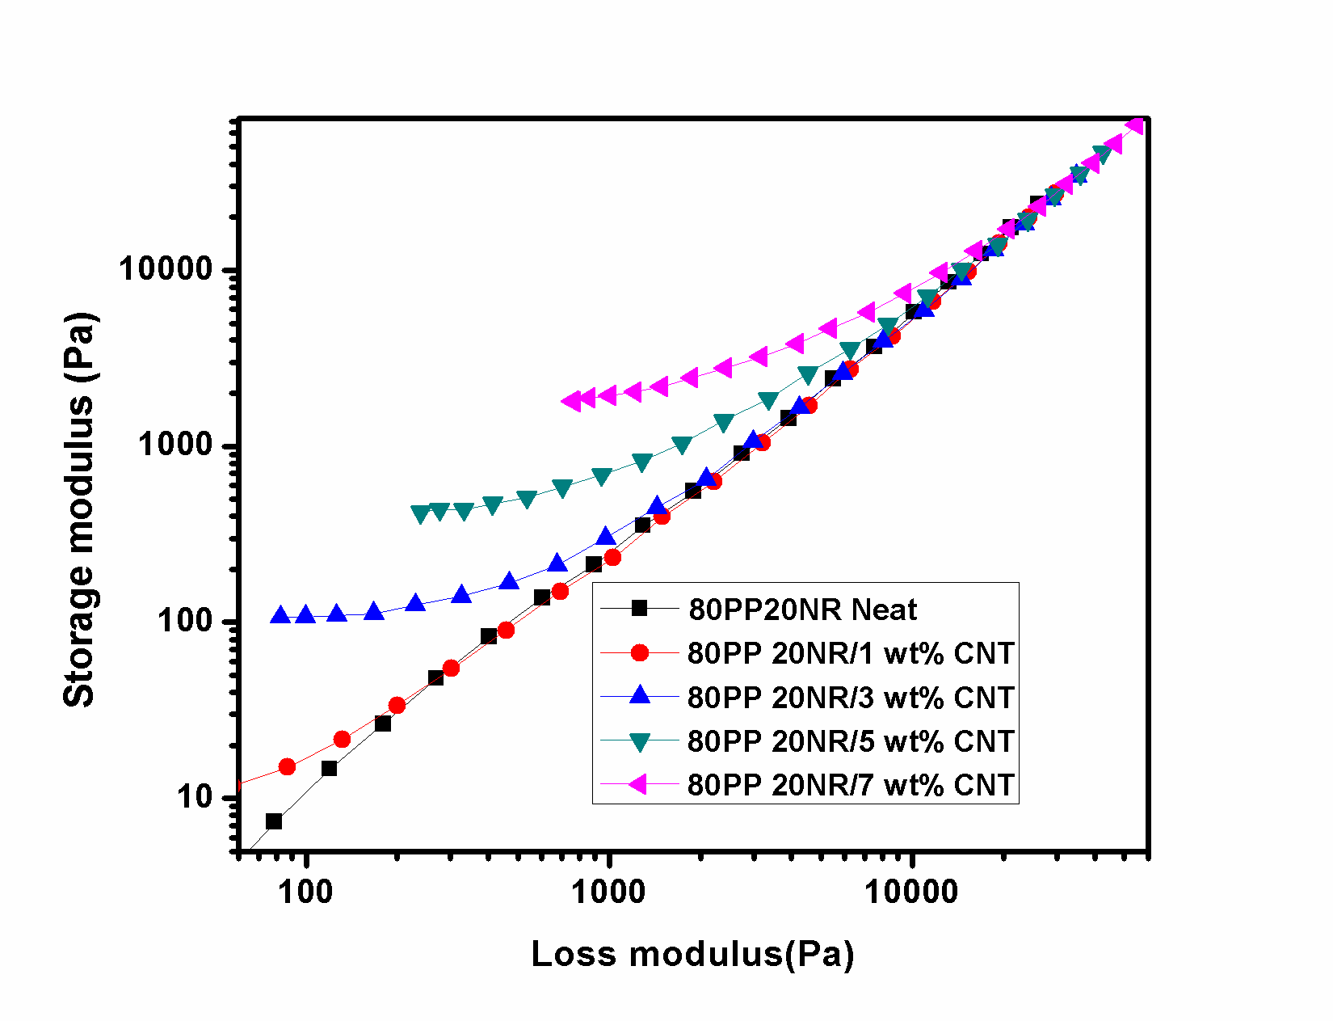

**a)**

**b)**

**c)**

***Fig 10. a)Damping factor vs frequency b) Storage modulus vs Loss modulus plot for 80PP/20NR/MWCNT composites c) Cole Cole Plot***

Figure 10a gives the relationship between the applied frequency and the tangent loss angle (tan*δ*) for the composites with different MWNT loadings with respect to the oscillator frequency. In contrast to neat blend and blend with 1 wt% CNT (no MWNT), the composites exhibit lower tan*δ*, at above 3wt%CNT loading. Tan*δ values* obtained from rheological study is used to characterize the viscoelasticity of a material, and lesser the value of tan*δ* means that the material is exhibiting relatively more solid-like behavior. As shown in Figure 10, the addition of MWNTs into the composites increases the solid-like viscoelastic behavior of the composites and decreases the liquid-like behavior at a given oscillatory frequency, which is attributed to the formed nanotube network in the composites.

Fig. 10b shows curves of storage modulus G’ versus loss modulus G” as a function of frequency for 80PP/20NR blends and its composites. It has been reported that such plots can be used to identify structural difference between neat and particle filled polymers . Polymer nanocomposites near the percolation threshold show a shift or change in the slope of G’ vs. G” plots due to the formation of network structure. Below the percolation threshold, rheological and processing behavior of the nanocomposites is very similar to the unfilled polymer. However, above the percolation threshold the CNTs impede the motion of the polymer. In the present study, a significant shift in slope of G’ vs. G” plots is started at 3wt% CNT loading. Thus, this concentration of CNTs is regarded as rheological percolation threshold for PP/NR/MWCNT composites. This study confirms that the MWCNTs has a significant effect on the microstructure of PP/NR blends.

Cole Cole plots of the imaginary part against real part of dynamic viscosity for the 80PP/20NR blend and nanocomposites are shown in fig 10(c). The figure exhibit two characteristic relaxation mechanism corresponding to droplet matrix morphology of the composites.[38] It is observed that curves of all the nanocomposites are profoundly deviated from the curve of neat blend and showed more evident of upturning at high viscosity with the increase of MWCNT, implying the existence of a longer relaxation time due to the presence of interconnected network structure.

**3.2.3 Rheology of 50PP/50NR/MWCNT composites**

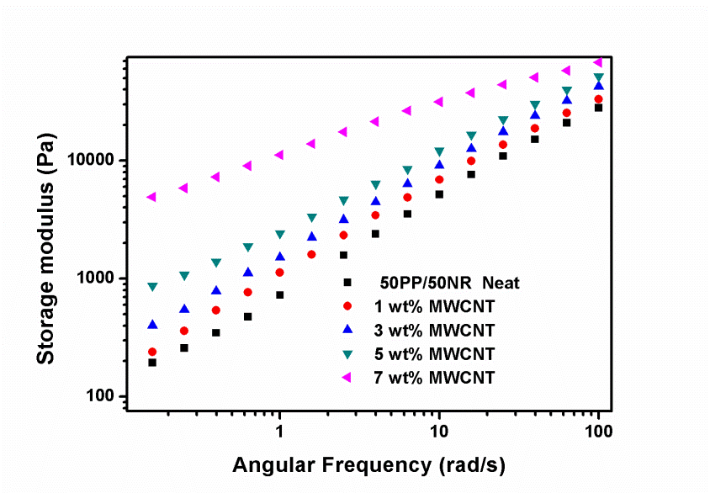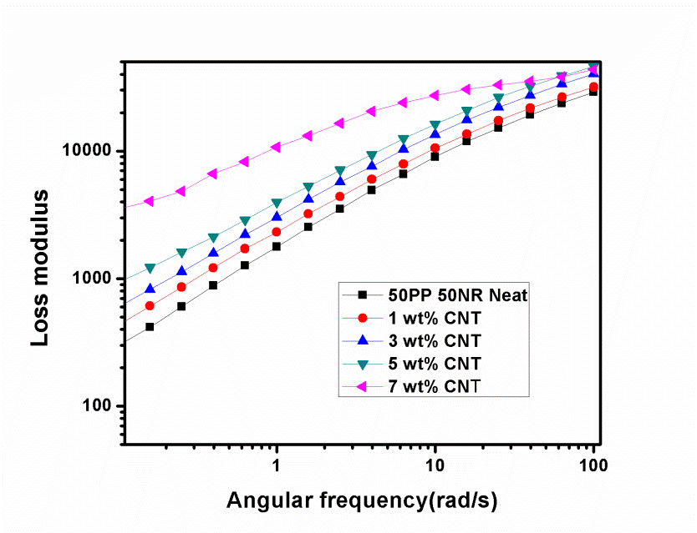

a)

b)

***Fig 11. a).Storage modulus Vs frequency and (b) Loss Modulus Vs frequency for 50PP/50NR/MWCNT nanocomposites***

Fig11 shows the variation in storage modulus, loss modulus of 50PP/50NR blend and its composites. From Fig.11a) it can be observed that the addition of MWCNT increases the storage modulus of 50PP/50NR blend system. Unlike 80PP/20NR system a continuous network is formed in the neat 50PP/50NR blend due to to its co-continuous morphology. Addition of 3wt% MWCNT produces a double percolation effect because of the selective localization of multiwalled carbon nanotubes in the NR phase i.e a percolated network of MWCNTs are formed within the continuous NR phase. This will reduce the rheological percolation threshold of 50PP/50NR/MWCNT system than that of PP/MWCNT system. The double percolation effect become more prominent with increasing the MWCNT content and it enhances the storage modulus of the system. Fig 11b shows that loss modulus follows the same trend as that of the storage modulus.

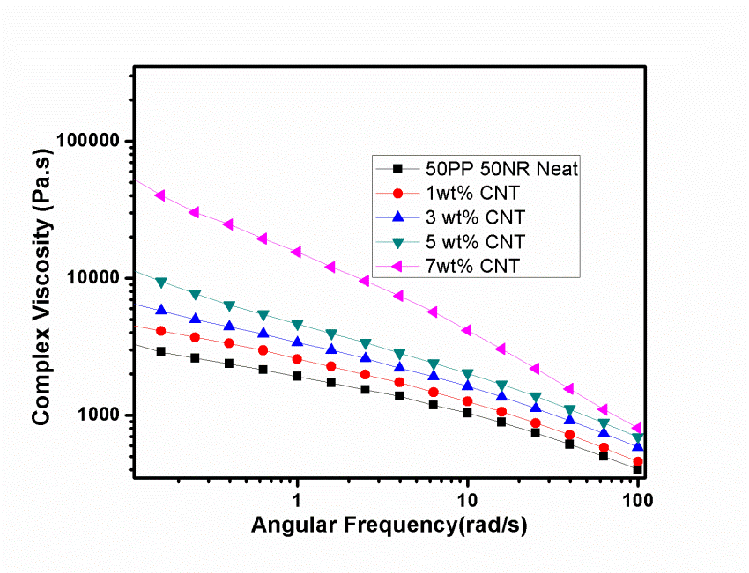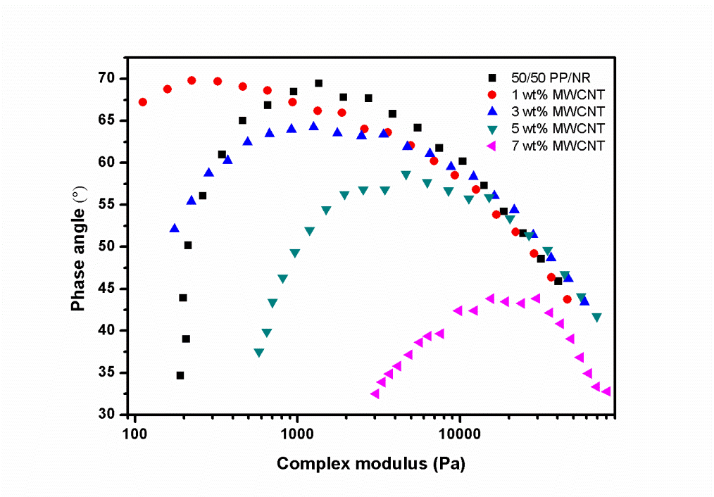

a)

b)

Fig 12.a)Complex viscosity vs frequency b) Van Gurp Palmen plot for 50PP/50NR/MWCNT composites

Fig 12 shows the variation in complex viscosity with frequency and van Gurp-Palmen plot for MWCNT filled 50/50 PP/NR blend. Fig 12(a) shows that complex viscosity of the blends increases with increasing the concentration of MWCNT. This clearly indicates that the percolated network of MWCNTs hinders the motion of polymer chains. It is observed that 50/50 PP/NR blend without MWCNT shows shear thinning behaviour over the complete range of frequencies , which is an indication of the highly interconnected NR phase in the PP matrix ie co-continuous morphology of the blend. In the van Gurp-Palmen plot (Fig. 12(b), the phase angle further lowered due to increased elasticity (due to high fraction NR). The nature of the van Gurp-Palmen curve can give indication of the blend morphology i.e., either matrix – droplet or co-continuous morphologies.[39],[40] The van Gurp-Palmen plots of 50/50 PP/NR blend (Fig. 12b) shows a significant change in phase angle due to the interconnected morphology. The nature of van Gurp-Palmen plot of 50/50 PP/NR blend indicates the first percolation in a co-continuous blend.[41] The second percolation occurs above 1 wt% MWCNT in 50/50 PP/NR blend. In brief, this double percolation effect indicates the selective dispersion and percolation of MWCNT in NR phase, and the continuity of this NR phase in the blend system.

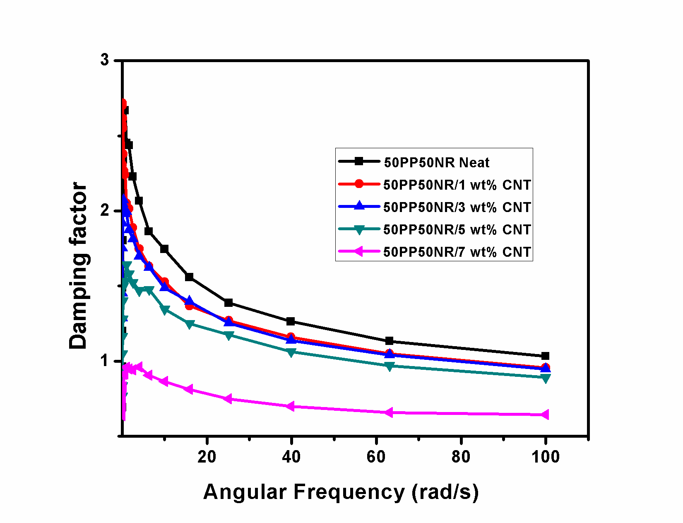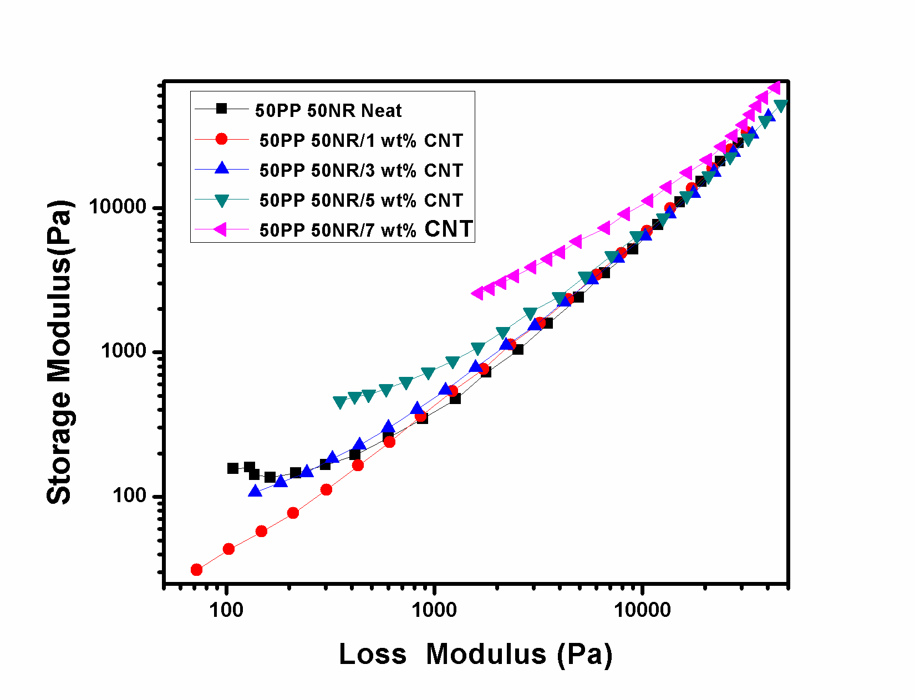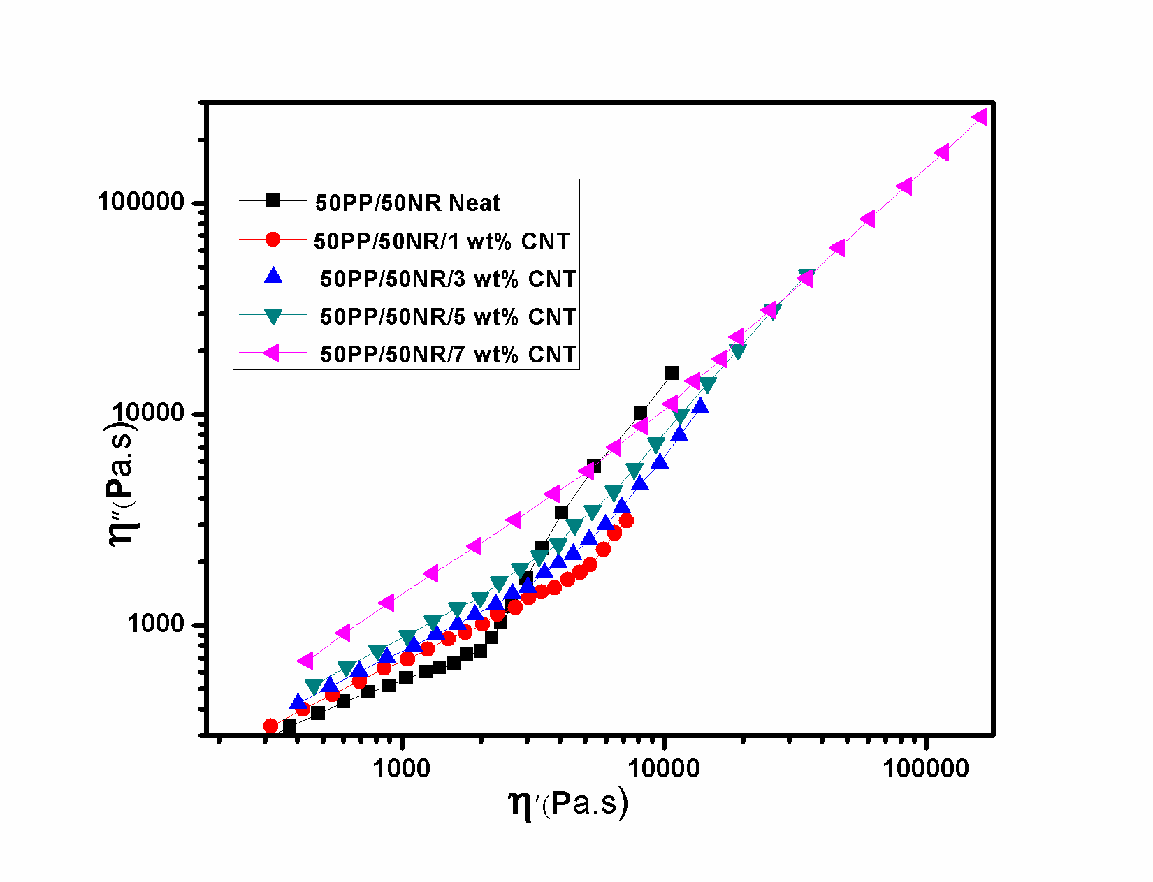

**a)**

**b)**

**c)**

***Fig 13 Damping factor vs frequency b) Storage modulus vs Loss modulus plot for 50PP/50NR/MWCNT composites c) Cole Cole plot***

Figure 13(a) gives the relationship between the applied frequency and the tangent loss angle (tan*δ*) for the composites with different MWNT loadings with respect to the oscillatory frequency. At low values of tan*δ* the stress is dissipated through the samples by molecular movements. At high range of tan*δ*, on the other hand, the elasticity is increased because there is not enough time for polymers to relax[42] Therefore, the materials damping is relatively very low. Tan*δ* value of PP/NR/MWCNT composites decreases with increasing the MWCNT content and it indicates that elasticity of the composites increases due to the formation of CNT network within blend system.

Fig.13(b) shows the curves of storage modulus G’ as a function of loss modulus G” for PP/NR/MWCNT blends. . It can be seen that the G'-G” curves of PP/NR/MWCNT blends are significantly changed from the curves of neat blend. It was proposed that G'-G” curves should be similar at a fixed temperature if the microstructure does not alter.[43]. There is prominent change in the slope of G’ vs G” curve nearer to the percolation threshold. Now, it is widely reported that both the plateau in the low frequency region of modulus curve and the deviation from a linear relationship between G’ and G” are indicative of the formation of a percolated network.[44],[45] Thus addition of MWCNTs changes the microstructure of the PP/NR blends and make more complicated influence on relaxation behaviour of composites. This confirms that MWCNT net works are formed within the NR phase and it produce refinement in the morphology with increasing the CNT content.

Fig 13 (c) represents the cole cole plot of 50PP/50NR blends and its nanocomposites. The presence of arc and large tail represents the co continuous morphology of the blend and composites. On increasing the MWCNT content the plots showed more evident of upturning at high viscosity, implying that the presence of MWCNT network atructure slow down relaxation process.

**3.2.4Rheological Studies of 20PP/80NR/MWCNT composites**.

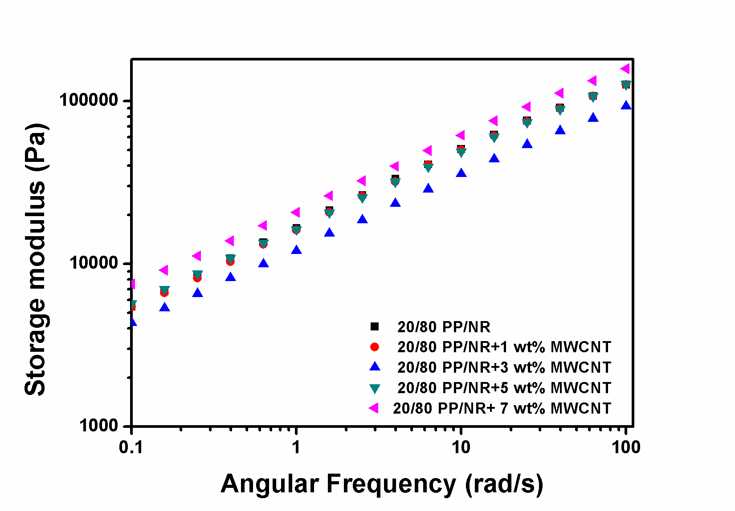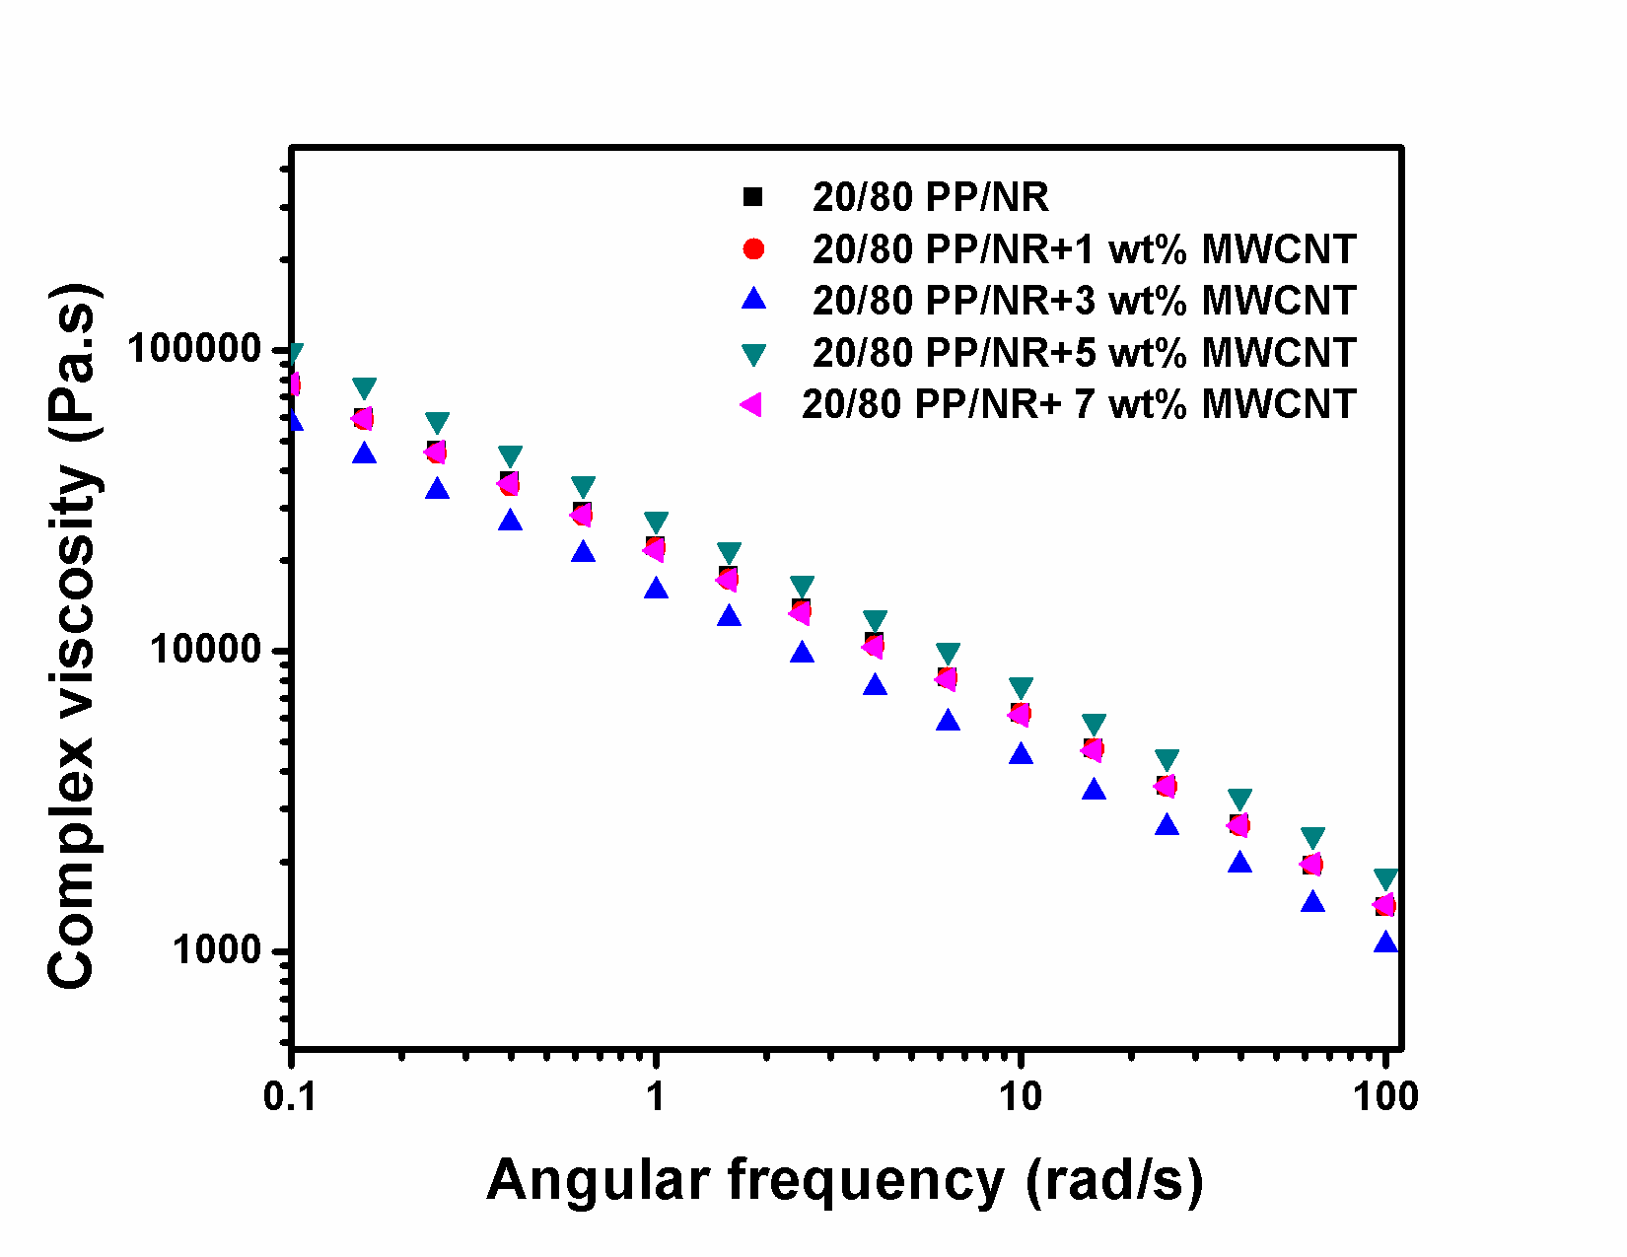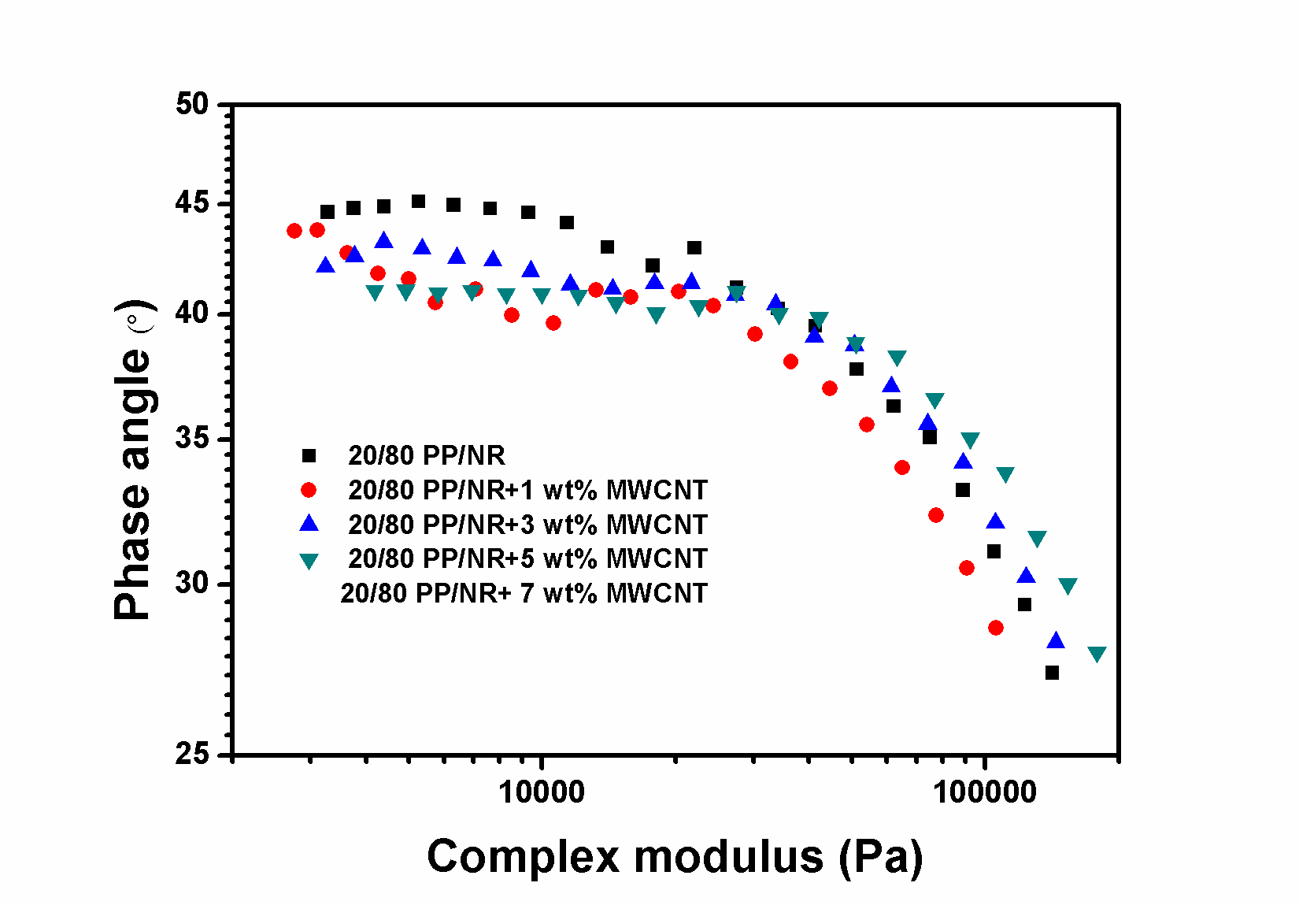

a

b

c

***Fig.14 Variation in storage modulus, complex viscosity with frequency and van Gurp-Palmen plot for MWCNT filled 20PP/80 NR blends***

**Fig.14** shows the variation in storage modulus, complex viscosity with frequency and van Gurp-Palmen plot for MWCNT filled 20/80 PP/NR blends. For MWCNT filled 20/80 PP/NR blends, the melt rheological behaviour is different from that of blend having PP as major or equal component .Due to the elastic nature of the matrix melt, the sol-gel transition due to MWCNT network generation cannot be easily predicted from the storage modulus vs frequency or complex viscosity vs frequency plots .However, the van Gurp-Palmen plot (**Fig.14c**) gives some information regarding percolation in MWCNT filled 20/80 PP/NR blends. The nature of curve at low complex modulus shows deviation above 1 wt% MWCNT

**3.3 Effect of CNT loading on the tensile properties of 80PP/20NR blend systems**

Stress-strain graphs for the 80PP/20NR blend and its composites with varying amount of CNT is plotted and shown in Figure 15. The tensile parameters such as tensile modulus, tensile strength, elongation at break and tensile toughness of the blend and composites are tabulated in table 1. A brittle to ductile transition in CNT filled PP/NR blend occurs at 3 wt% of CNT content. The brittle to ductile transition is usually used to evaluate the toughening efficiency of the elastomers in elastomer-toughened polymer blends. From Figure.15, it is evident that a low amount of CNT (3 wt%) is sufficient to impart ductility in 80PP/20NR blend system. Further increase in concentration of CNT (up to 5 wt%), increases the ductility. However, above 5wt% of CNT, the ductility is found to decrease along with a drop in tensile strength.



***Fig 15.Stress Strain curve of 80pp/20NR blend and its composites with different CNT content***

**Table 1. Tensile properties of 80PP/20NR blends and its composites with different CNT content**

|  |  |  |  |  |
| --- | --- | --- | --- | --- |
| **Sample** | **Modulus**  **(MPa)** | **Tensile strength (Mpa)** | **Elongation at break (%)** | **Tensile Toughness**  **(J/m3)** |
| 80PP20NR-neat | 829.66±30.1 | 16.125±0.56 | 5.525±2.7 | 35.44±1.6 |
| 80PP20NR/ 1wt%CNT | 957.66 ±38.73 | 16.785±0.28 | 9.835±1.5 | 69±5.6 |
| 80PP20NR/ 3wt%CNT | 890.5±44.54 | 13.312±0.56 | 15.81±4.5 | 159±41 |
| 80PP20NR/ 5wt%CNT | 772±12.31 | 12.538±0.31 | 24±1.7 | 248.4±27.23 |
| 80PP20NR/ 7wt%CNT | 859± 16.97 | 11.91±0.44 | 18.91±0.31 | 176.89±27.96 |

Unlike single polymer matrix, the reinforcement of filler in binary polymer blend is depend on the complex morphology factors such as blend morphology and location of filler among the blend components.Both morphological studies and theoretical evaluation based on thermodynamic prediction in CNT filled 80PP/20NR blends confirms the selective affinity of CNTs towards NR phase. Moreover, above 1% CNT content the ductile NR domain gets highly elongated and become irregularly shaped due to the presence of selectively localized MWCNTs in the NR phase. i.e morphology changes from matrix droplet to quasi co-continuous structure. The observed tensile behaviour could be better explained based on these features. The young’s modulus and tensile strength increase slightly with the incorporation of 1 w% of CNT and then starts to decrease with increase in concentration. The blend morphology of 80PP/20NR blend is almost similar with that of 1 wt% CNT filled 80PP/20NR blend with slight variation in NR domain size. As the concentration of CNT increases, the tendency to curl and reside inside the NR droplet increases and hence the portion of CNT available for bridging into PP phase decreases. Hence, sufficient amount of CNTs are not available to reinforce PP matrix in CNT filled PP/NR blends with higher CNT content (>1 wt%). Also, the blend morphology starts to change from a uniform dispersion of NR spheres to uneven distribution of irregular shaped NR phase. This may have some role in deterioration of tensile modulus and strength. At the strain values at which yielding happens, the presence of quasi continuous rubber phase could allow the whole material to yield at significantly lower strengths than the material with a perfect “matrix-droplet” morphology, and consequent continuous stiff matrix.

The area under the stress–strain curve is usually used to indicate the energy absorption during the tensile process, which in turn represents the toughness. At 3 wt % CNT content, a statistically significant difference in elongation at break (when compared to neat blend) is observed. It is considered that this is the threshold concentration for the PP/NR system in question, where morphology stabilization of the system starts to occur. Because NR has much higher elongation at break than PP, the load bearing CNT was able to transfer load to the ductile NR phase. The net effect was improvement in the elongation at break for the composite. The spherical NR domain changes to elongated, irregular shaped domain due to the presence of selectively localized MWCNTs in the NR phase. This might be another reason for increase in the tensile ductility with increase in CNT content. In 80PP/20NR blend, NR phase alone is insufficient to generate a prominent tensile toughening effect. A CNT concentration of 3 wt% and 5 wt% are effectively toughen the blend matrix.

**3.4 Effect of MWCNT loading on the tensile properties of 50PP/50NR blend systems**

Figure. 16 shows the stress strain graph of 50PP/50NR blend and its composites with different CNT loading. The tensile modulus, tensile strength, elongation at break and tensile toughness of the samples are tabulated in table 2. When compared with 80PP/20NR blend, the modulus and tensile strength of 50PP/50NR blend reduced to 60.8 % and 67.1 % respectively due to the elastic nature of the blend.In 80PP/20NR blend, the tensile modulus and strength are determined by major PP phase. While in 50PP/50NR blend, both NR and PP equally contribute toward modulus and strength of the blend.



***Fig 16. Stress -strain curve of 50PP/50NR blends and its composite with varying CNT loading.***

**Table 2. Tensile properties of 50 PP/50 NR blend and its composites**

|  |  |  |  |  |
| --- | --- | --- | --- | --- |
| Sample | Modulus (MPa) | Tensile strength (MPa) | Elongation at break (%) | Toughness (J/m3) |
| 50PP50NR Neat | 325±3.2 | 5.298± 0.24 | 8.36± 1.15 | 39.34±0.28 |
| 50PP50NR/1wt % CNT | 294± 3 | 5.43± 0.17 | 13.31± 3.07 | 61.6±2.27 |
| 50PP50NR/3wt % CNT | 236.5±1.5 | 3.67± 0.12 | 33.6±1.6 | 116.66±5.68 |
| 50PP50NR/5 wt% CNT | 256± 5 | 3.54± 0.11 | 58.3±2.6 | 168.76±4.6 |
| 50PP50NR/7 wt% CNT | 318±6 | 3.79±0.37 | 37.9±7.14 | 108.80±6.1 |

Upon addition of CNT, the tensile strength and young’s modulus of 50PP/50NR blends further decreases. On the other hand, largely enhanced tensile ductility is achieved for the blend composite specimens, especially at relatively high CNT content. For example, blend with 5 wt% CNT exhibits an elongation at break 6 times higher than that of the neat blend and 2.4 times higher than that of 80PP/20NR blend with 5 wt% of CNT. To date, several researches have already shown that incorporating CNTs into the immiscible polymer blends and simultaneously tailoring the selective localization of CNTs in the blend composites, CNTs can improve the tensile ductility of the blend composites. The ‘dual network structure’ described as selective dispersion of MWCNT in NR phase and the continuity of this NR phase in MWCNT filled 50PP/50NR blend has contributed towards the enhanced tensile ductility. CNT network structure within the continuous NR phase promote the stress transferring between components and will results in the homogeneous dispersion of stress field in the specimen, which contributes to the large enhancement of the tensile ductility.

**3.3**  **Effect of MWCNT loading on impact strength of PP/NR blends**

Impact strength of a material can be measured in the term of various parameters to validate mechanical properties for the industrial applications. As compared to other mechanical testing, impact strength measurement is easy, very common and widely accepted. In this regard, impact strength can be defined as “ability of a solid to absorb impact energy and shock without any external damage.

a)**C:\Users\SHARIKA\Desktop\Graph3.tif**b) ***C:\Users\SHARIKA\Desktop\Graph2.tif***

***Fig 17. Impact properties of a) 80PP/20NR/MWCNT composites b) 50PP/50NR/MWCNT composite***

Figure 17a shows the variation of impact strength of 80PP/20NR blend with different contents of CNTs. In this work, the impact strength of pure PP measured in the same conditions is 3700 J/m2. Although NR has been proved as an effective impact modifier for PP, the toughening effect is very inconspicuous. The notched Izod impact strength measured for this 80PP/20NR blend is only 3780.65J/m2. This can be ascribed to the poor miscibility of PP/NR resulting in larger NR particles and weak interfacial bonding between PP and NR. Previous research results have shown that PP blends with smaller elastomer particles are tougher and more ductile than those with larger particles, probably because these blends represent a more efficient use of rubbery phase in promoting crazing and/or shear yielding of matrix.

Figure 17b shows the variation of impact strength of 50PP/50NR blend with different contents of CNTs. The notched Izod impact strength measured for this 50PP/50NR blend is 5408 J/m2. The co-continuous morphology generated in 50PP/50NR blend is more favourable for the improvement of impact strength than the matrix droplet morphology in 80PP/20NR blend. In both 80PP/20NR and 50PP/50NR blends, the impact strength increases with the increasing content of CNTs. However, Figure.18 shows that CNTs induces somewhat greater improvement of impact strength on 50PP/50NR blends than on 80PP/20NR blends. The impact strength is enhanced from 5408J/m2 for unfilled 50PP/50NR to 12806.22J/m2 for 5 wt% CNTs filled 50PP/50NR blend.



***Fig 18. Effect of blend ratio on the impact properties of PP/NR/MWCNT composites***

In CNT filled 80PP/20NR blend, the interfacial bonding between PP and NR is largely strengthened through the bridge effect of CNTs (as evident from morphological study), which prevents the propagation of crack in the interface of PP and NR, leading to the improvement of impact strength. At the same time, in 50PP/50NR system, besides the network structure of CNTs, NR also form the continuous network structure with in PP matrix. Here, the concept of ‘dual-network structure’ is very similar to the ‘double percolation’ concept first introduced by Sumita et al. in investigating the electrical properties of conductive materials. Thus network structure of CNTs in co-continuous PP/NR (50/50) is more preferred than that in PP/NR (80/20) with matrix droplet morphology and is responsible for the great improvement in the impact toughness of 50PP/50NR composites compared to 80PP/20NR system.

Also the incorporation of MWCNTs greatly increases the viscosity of the dispersed phase, and higher viscosity leads to finer morphology in the case of co-continuous system. Obviously, the decreased particle size is favourable to the improvement of the toughness as proved by tensile measurement. The weak toughening effect of MWCNTs at higher concentration of 7 wt% in both the system (80PP/20NR and 50PP/50NR) can probably be attributed to the aggregation of MWCNTs in the blends irrespective of blend morphology, which results in the presence of defects in the nanocomposites. Similarly, CNT agglomerates play the role of stress concentrators, which leads to the deterioration of the impact resistance under stress.

However, it is worth noting that the degree of the enhancement in impact strength is lower than that in the tensile ductility. It may be due to the different load conditions applied for the tensile and impact measurements which results in the different mechanical responses.

**3.3.2 Toughening mechanism**

The toughening mechanism operated in PP/NR/MWCNT nanocomposites was proposed based on the morphology evolution and the formation of CNT network structure within the blend system. The morphological studies of nanocomposites shows that 80PP/20NR blends exhibit a matrix-droplet morphology and MWCNTs are selectively located in the NR phase. At low concentration of MWCNTs (1 wt%), the nanotubes tend to aggregate together due to the length of a single carbon nanotube range much longer than the diameter of NR particles. But at high MWCNTs content (≤ 3 wt%), some of these clusters migrate to PP phase, possibly inducing the local network structure or aggregation of MWCNTs in PP and around NR domains. These MWCNTs which are locate in or penetrate the interfaces, namely, MWCNTs with nano-dimensional size exhibit the nano-bridge effect for the immiscible PP/NR blends. [29] Obviously, such nano-bridge effect intensifies the interfacial adhesion between NR and PP components dramatically, preventing the crack initiation and crack propagation in the interfaces, and finally leading to the great improvement of the toughness of the immiscible blends with matrix droplet morphology. Especially, when the crack propagates along the interface between PP and NR, MWCNTs which penetrate the interfaces will be elongated, pulled out from the crack-planes, leading to more energy absorption. Consequently, largely enhanced toughness is observed for these nanocomposites.

Morphological analysis reveals that 50PP/50NR blends exhibit a co-continuous morphology and CNTs preferentially occupied in the NR phase. CNTs exhibit good dispersion in NR phase due to the largely increased NR phase and the good interaction between NR and CNTs. [Debundled](https://glosbe.com/en/en/debundling) CNTs appeared as linear interconnected CNT, which comes under high aspect ratio nano objects with fast interfacial transfer and low interfacial stability during melt mixing process of two immiscible blends. [29] During the fracture process, the stress is easily to be transferred between matrix and NR phase through the network structure of MWCNTs, inducing more homogeneous distribution of stress and avoiding the severe stress concentration which leads to the prematurely fracture of sample, leading to the improvement of fracture toughness. However, increase in CNT loading to 7wt% shows a slight decrease in impact strength which might correlate to the agglomeration of which can act as a weak point for crack initiation.’

* 1. **Electrical Properties of PP/NR/MWCNT composites**

**3.5.1 Electrical Conductivity studies**

**AC Conductivity**

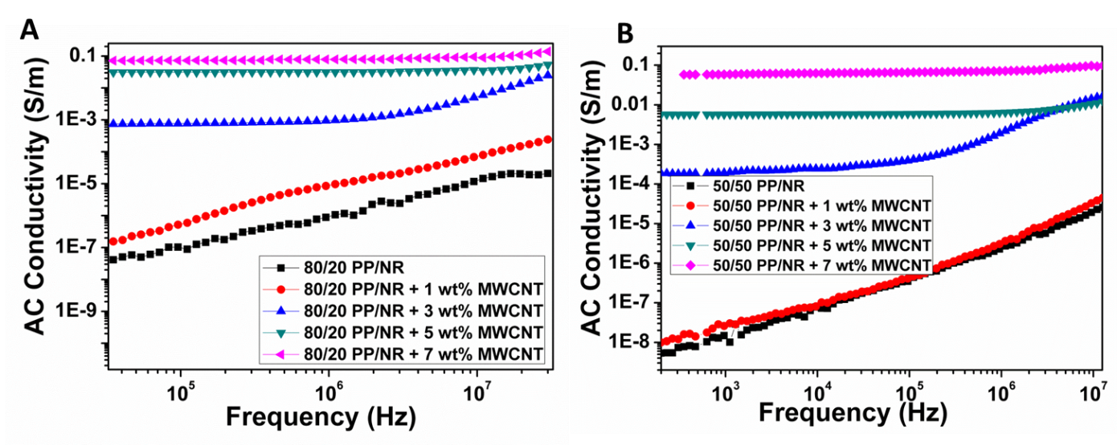

***Figure 19:*** *AC electrical conductivity as a function of frequency of (A) 80/20 PP/NR blends and (B) 50/50 PP/NR blends with different loading of MWCNT*

Inter-connected networks of nanoparticles is a primary requisite in enhancing the charge transport in insulating polymer blend. When the conducting nanoparticles are selectively localized in one of the phases of an immiscible polymer blend, it will enhances the effective concentration of the particles in the blend, which in turn results in improved conductivity. The electrical conductivity of different blends at room temperature was assessed using broadband dielectric spectroscopy. Figure 19 shows the AC conductivity as a function of frequency for PP/NR (80/20) blends and PP/NR (50/50) blends, containing different loading of MWCNT. Figure 5A displays that 80PP/20NR neat blend and blend with 1wt% MWCNT are insulating nature where conductivity increases rapidly with increase in frequency. For PP/NR blend with 3wt% MWCNT shows semiconducting nature. It is also observed that when MWCNT concentration exceeds the critical concentration, known as percolation threshold the conductivity of the blend has increased by several orders than the neat blend. Fig 19 A indicates that above 3wt% MWCNT content the composites exhibit a frequency independent behavior at low frequencies and the frequency independent plateau extended to a higher frequency. Formation of interconnected network of MWCNTs is necessary for the conduction of blend system. The morphological studies shows that most of MWCNTs are selectively localized at the NR phase of blend system and this increases the local concentration of MWCNTs in a given phase and facilitates the inter connected network-like structure even at lower loadings. Also from SEM & TEM images it is observed that this selectively localized MWCNTs, bridges the NR domain and certain MWCNTs are hang into the PP matrix. All these will lead to the high conductivity of the system. Such interconnected network structure assists tunneling of electrons, resulting to very high electrical conductivity in the composites.[46] At higher loading of MWCNT, number of MWCNT percolating paths are formed and the electrons can move freely in the entire frequency range, thus the frequency independence of the AC conductivity is observed. Figure 19B shows the AC electrical conductivity of different 50PP/50NR blends as a function of frequency with varying concentration of MWCNTs at room temperature. The neat blends and the blend with 1 wt% MWCNTs exhibit the typical behavior of an insulator where the conductivity increases with increasing frequency. Above 1 wt% MWCNTs, the electrical conductivity increased dramatically manifesting in the formation of the interconnected network-like structure of MWCNTs within the blend system. Both SEM & TEM images shows that the 50PP/50NR blends and composites have co-continuous morphology and the MWCNTs are selectively localized in the continuous NR phase. The distance between neighboring MWCNTs decrease greatly so that MWCNTs contact with each other. This further helps in efficient charge transport through tunneling or hopping mechanism. Such continuous structure induces the double percolation effect, which refers to the percolation of MWCNT in the NR phase and the continuity of the MWCNT-filled NR phase in the polymer blend.

**DC Conductivity**

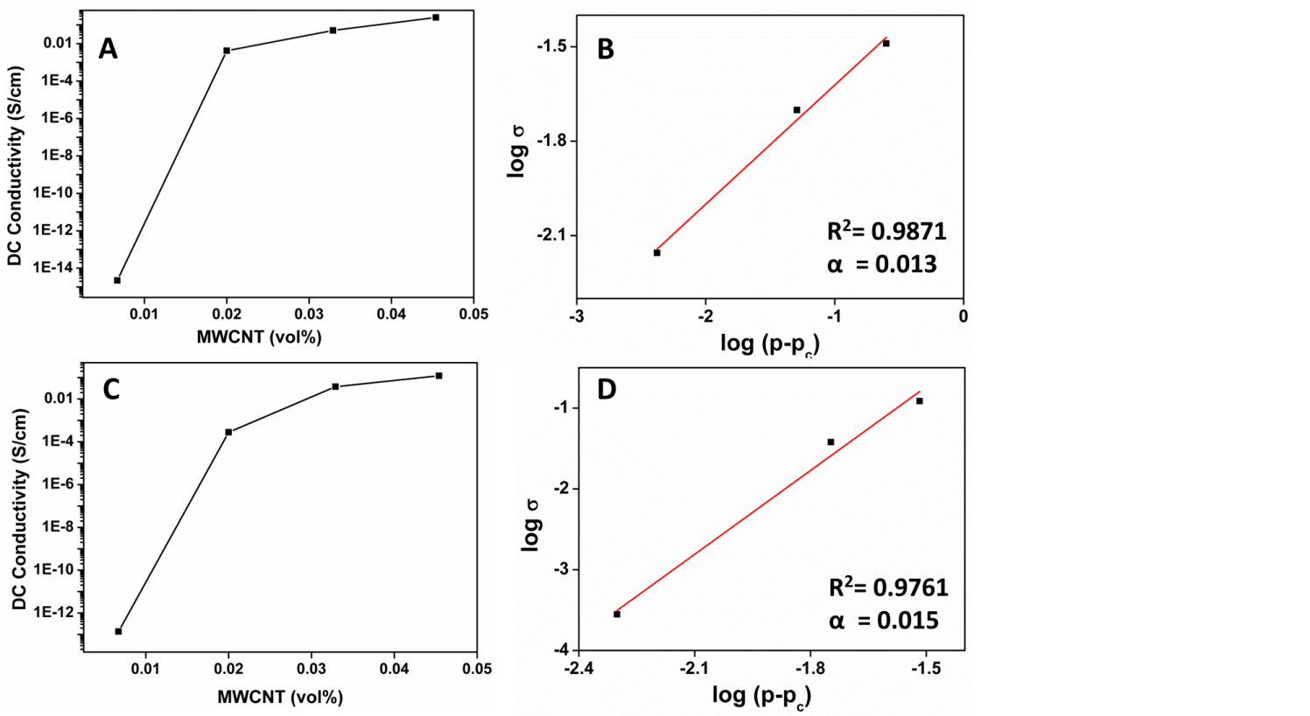

***Figure 20:*** *(A) Dependence of the DC conductivity of the 80PP/20NR/ MWCNT blend composites on the MWCNT volume fraction (B) shows the best fits of the conductivity to Equation 1. ( C&D) 50PP/50NR/MWCNT blend nanocomposites*

Figure 20 shows DC conductivity of 80PP/20NR and 50PP/50NR blend nanocomposites with various MWCNT loading. DC conductivity studies of our composites show good agreement with ac conductivity results (Increase in DC conductivity with MWCNT loading). Both 80PP/20NR and 50PP/50NR nanocomposite exhibit a conductivity increase of around 10 orders at low loadings, indicating the formation of percolating network of MWCNT. For example, the conductivity of the 80PP/20NR blend nanocomposites displays a dramatic increase of over 10 orders of magnitude as compares with neat blend (2.24X10-15 S/cm) and the conductivity reaches 0.002 S/cm at 0.02 vol%(3wt%) loading of MWCNTs. The conductivity increases with increasing CNT content but levels off after 0.03 vol%(~5wt%). This significant increase of conductivity for MWCNT content changing from 0.01 to 0.02 vol.% indicates a percolation threshold lower than 0.02 vol.%( ~3wt%). The percolation threshold of conductivity with filler loading can be theoretically determined using power law given below.

 **(1)**

Where σ is the electrical conductivity p is the volume fraction of MWCNT, pc is the electrical percolation threshold value, **α** is the critical exponent. The best linear fits of the conductivity data to the log σ vs log(p− pc) plots of the power law for Equation 1 gave Pc = 0.013 (1.9wt%) for 80/20 NR/PP blend nanocomposites and Pc = 0.015(2.2wt%) for 50/50 NR/PP blend nanocomposites. This low threshold value can be attributed to the large one dimensional aspect ratio and well dispersion of MWCNTs in the composites which improves the number of electrical contacts between individual nanotubes, i.e. formation of the saturated conductive network in the volume of the polymer matrix. This network forms conductive networks and thus increase the number of charge transport path. This high value of electrical conductivity will be useful for efficient EMI shielding response.

**4. Conclusion**

Various composition of natural rubber / polypropylene blends were prepared by melt mixing method using a hakae rheocorder . Multiwalled carbon nanotube filled PP/NR blends(80PP/20NR, 50PP/50NR 20PP/80NR)was successfully prepared using melt mixing technique using Brabender Plasticorder. Morphological studies shows that Multiwalled carbon nanotubes shows high affinity towards the NR phase. Scanning electron microscopy (SEM) studies show that the addition of MWCNTs changes the droplet morphology into quasi co-continuous morphology in the case of PP/NR 80/20 (wt/wt) system. However there is a refinement in the co-continuous morphology of PP/NR (50/50) by the addition of MWCNTs.

The effects of the blend morphology and selective localization of MWCNTs on the rheology, mechanical and electrical properties of PP/NR blends were systematically investigated. For each PP/NR blend composition the rheological percolation mechanism operated was found to be different. For 80 PP/20NR blend, the local concentration of MWCNTs in distorted droplets of NR phase facilitated effective percolated network of MWCNT with bridging of some of MWCNTs from the NR droplet to the PP continuous phase. A ‘double percolation’ phenomenon was observed in 50PP/50NR blend, where the MWCNT formed a percolating network inside the NR phase. The mechanical properties of PP/NR blends ( 80/20 & 50/50 wt/wt) have been extensively studied as a function of MWCNT loading. In both the blend system elongation at break and impact strength increases with increasing the MWCNT concentration. Selective localization of MWCNT in NR phase and the resulting morphology change is responsible for the enhancement in ductility of these blend composites.

Both 80PP/20NR and 50PP/50NR nanocomposites exhibit an electrical conductivity increase of around 10 orders of magnitude at low MWCNT loadings, indicating the formation of percolating network of MWCNT. This work provided a comprehensive study concerning the effects of phase morphology and MWCNT selective localization on the rheological, mechanical and electrical properties of PP/NR/MWCNT composites.

**5.References**

1. CHAPTER 2 NANOSTRUCTURED POLYMER BLENDS, Amos Adeniyi*, Oluranti Agboola*, Emmanuel Rotimi Sadiku*, M.O. Durowoju*, P.A. Olubambi*,

   A. Babul Reddy*, I.D. Ibrahim†, W.K. Kupolati‡
2. Polymer Blends: Phase Behavior and Property Relationship, Paul, D.R.
3. International Journal of Adhesion & Adhesives 29 (2009) 253–258
4. L. A. Utracki, POLYMER BLENDS HANDBOOK
5. Iijima, S. Nature 354, 56 (1991).
6. Anand, K. A., Jose, T. S., Agarwal, U. S., Sreekumar, T. V., Banwari, B., and

   Joseph, R. Int. J. Polym. Mater. 59, 438 (2010).
7. Ashrafi, B., and Hubert, P. Compos. Sci. Technol. 66, 387 (2006).
8. Bal, S., and Samal, S. S. Bull. Mater. Sci. 30, 379 (2007).
9. Jammak, J.; Cheng, S.; Zhang, A.; Hsieh, E. Polymer 1992, 33,

   728
10. Journal of Applied Polymer Science, Vol. 89, 2657–2663 (2003)

    © 2003 Wiley Periodicals, Inc.
11. Tao F, Auhl D, Baudouin AC, Stadler FJ, Bailly C. Influence of multiwall carbon

    nanotubes trapped at the interface of an immiscible polymer blend on interfacial tension. Macromol Chem Phys 2013;214(3):350–60.
12. Monemian S, Jafari SH, Khonakdar HA, Goodarzi V, Reuter U, Pötschke P. MWNT-filled PC/ABS blends: correlation of morphology with rheological and electrical response. J Appl Polym Sci 2013;130(2):739–48.
13. Liebscher M, Blais MO, Pötschke P, Heinrich G. A morphological study on the dispersion and selective localization behavior of graphene nanoplatelets in immiscible polymer blends of PC and SAN. Polymer 2013;54(21):

    5875–82.
14. Sumita M, Sakata K, Asai S, Miyasaka K, Nakagawa H. Dispersion of fillers andthe electrical conductivity of polymer blends filled with carbon black. Polym Bull 1991;25(2):265–71.
15. Shen Y, Guo ZH, Cheng J, Fang ZP. J Appl Polym Sci 2010;116(3):1322–8.
16. Valentini L, Biagiotti J, Kenny JM, López Manchado MA. J Appl Polym Sci 2003;89(10):2657–63
17. Meincke O, Kaempfer D, Weickmann H, Friedrich C, Vathauer M,

    Warth H. Polymer 2004;45(3):739–48
18. Bendjaouahdou C, Bensaad S. The effects of organoclay on the morphology and balance properties of an immiscible polypropylene/natural rubber blend.

    Energy Proc 2013;36:574–90.
19. Biswas S, Kar GP, Bose S. Simultaneous Improvement in Structural Properties and Microwave Shielding of Polymer Blends with Carbon Nanotubes. ChemNanoMat. 2016 Feb 1;2(2):140-8.
20. Li LY, Li SL, Shao Y, Dou R, Yin B, Yang MB. PVDF/PS/HDPE/MWCNTs/Fe3O4 nanocomposites: Effective and lightweight electromagnetic interference shielding material through the synergetic effect of MWCNTs and Fe3O4 nanoparticles. Current Applied Physics. 2018 Jan 31.
21. Gubbels F, Blacher S, Vanlathem E, Jérôme R, Deltour R, Brouers F, Teyssie P. Design of electrical composites: determining the role of the morphology on the electrical properties of carbon black filled polymer blends. Macromolecules. 1995 Sep;28(5):1559-66.
22. Poyekar AV, Bhattacharyya AR, Panwar AS, Simon GP. Evolution of phase morphology and ‘network‐like’structure of multiwall carbon nanotubes in binary polymer blends during melt‐mixing. Polymer Engineering & Science. 2015 Feb 1;55(2):429-42.
23. Nuzzo A, Bilotti E, Peijs T, Acierno D, Filippone G. Nanoparticle-induced co-continuity in immiscible polymer blends–A comparative study on bio-based PLA-PA11 blends filled with organoclay, sepiolite, and carbon nanotubes. Polymer. 2014 Sep 15;55(19):4908-19.
24. Wu G, Li B, Jiang J. Carbon black self-networking induced co-continuity of immiscible polymer blends. Polymer. 2010 Apr 20;51(9):2077-83.
25. Otero-Navas I, Arjmand M, Sundararaj U. Carbon nanotube induced double percolation in polymer blends: Morphology, rheology and broadband dielectric properties. Polymer. 2017 Apr 7;114:122-34.
26. X.-Q. Liu, Q.-Y. Wang, R.-Y. Bao, W. Yang, B.-H. Xie and M.-B. Yang, RSC Adv., 2014, 4, 49429–49441
27. Otero-Navas I, Arjmand M, Sundararaj U. Carbon nanotube induced double percolation in polymer blends: Morphology, rheology and broadband dielectric properties. Polymer. 2017 Apr 7;114:122-34.
28. J. Urquijoa, N. Aranburua, S. Dagréoub, G. Guerrica-Echevarríaa,⁎, J.I. Eguiazábala European Polymer Journal 93 (2017) 545–555
29. Vleminckx G, Bose S, Leys J, Vermant J, Wübbenhorst M, Abdala AA, et al. Effect

    of thermally reduced graphene sheets on the phase behavior, morphology, and electrical conductivity in poly(r-methyl styrene)-co-(acrylonitrile)/ poly(methyl-methacrylate) blends. ACS Appl Mater Interfaces 2011;3(8):3172–80
30. Bose S, Özdilek C, Leys J, Seo JW, Wübbenhorst M, Vermant J, et al. Phase separation as a tool to control dispersion of multiwall carbon nanotubes in polymeric blends. ACS Appl Mater Interfaces 2010;2(3):800–7.
31. Bangarusampath DS, Ruckdäschel H, Altstädt V, Sandler JKW, Garray D, Shaffer

    MSP. Rheology and properties of melt-processed poly(ether ether ketone)/multi-wall carbon nanotube composites. Polymer 2009;50(24):5803–11.
32. Chatterjee T, Krishnamoorti R. Rheology of polymer carbon nanotubes composites. Soft Matter 2013;9(40):9515–29.
33. Pan Y, Li L. Percolation and gel-like behavior of multiwalled carbon nanotube/ polypropylene composites influenced by nanotube aspect ratio. Polymer

    2013;54(3):1218–26.
34. George S, Ramamurthy K, Anand JS, Groeninckx G, Varughese KT, Thomas S. Rheological behaviour of thermoplastic elastomers from polypropylene/

    acrylonitrile–butadiene rubber blends: effect of blend ratio, reactive

    compatibilization and dynamic vulcanization. Polymer 1999;40(15):4325–44.
35. Teng CC, Ma CCM, Huang YW, Yuen SM, Weng CC, Chen CH, et al. Effect of

    MWCNT content on rheological and dynamic mechanical properties of

    multiwalled carbon nanotube/polypropylene composites. Composites Part A

    2008;39(12):1869–75.
36. W.S. Chow, A.A. Bakar, Z.A.M. Ishak, J. Karger-Kocsis, U.S. Ishiaku, Effect of maleic

    anhydride-grafted ethylene–propylene rubber on the mechanical, rheological and

    morphological properties of organoclay reinforced polyamide 6/polypropylene

    nanocomposites, Eur. Polym. J. 41 (2005) 687–696
37. Ali Reza Zanjanijama, Shokoufeh Hakima,∗, Hamed Azizib Rheological, mechanical and thermal properties of the PA/PVB blends and their nanocomposites: Structure-property relationships Polymer Testing 66 (2018) 48–63
38. RUNMING LI,1,2 WEI YU,1 AND CHIXING ZHOUJournal of Macromolecular Sciencew, Part B: Physics, 45:889–898, 2006
39. Li R, Yu W, Zhou CX. Rheological characterization of droplet matrix versus cocontinuous

    morphology. J Macromol Sci B 2006;45(5):889–98.
40. .Jiang G, Huang HX, Chen ZK. Rheological responses and morphology of polylactide/linear low density polyethylene blends produced by different

    mixing type. Polym-Plast Technol Eng 2011;50:1035–9.
41. . Sumita M, Sakata K, Asai S, Miyasaka K, Nakagawa H. Dispersion of fillers and

    the electrical conductivity of polymer blends filled with carbon black. Polym

    Bull 1991;25(2):265–71.
42. . Feyz E, Jahani Y, Esfandeh M, Ghafelehbashi M, Jafari SH. J Appl Polym Sci

    2010;118:1796.
43. . W. Zou, R.Y. Chen, G.Z. Zhang, H.C. Zhang, J.P. Qu, Mechanical, thermal and

    rheological properties and morphology of poly (lactic acid)/poly (propylene

    carbonate) blends prepared by vane extruder, Polym. Advan. Technol. 27

    (2016) 1430e1437
44. . Khare RA, Bhattacharyya AR, Kulkarni AR, Saroop M, Biswas A. J

    Polym Sci Part B: Polym Phys 2008;46(21):2286–95.
45. . Cheng HKF, Sahoo N G, Pan YZ, Chan SH, Zhao JH, Chen G. J Polym Sci

    Part B: Polym Phys 2010;48(11):1203–12.
46. 46.Sharma M, Singh MP, Srivastava C, Madras G, Bose S. Poly (vinylidene fluoride)-based flexible and lightweight materials for attenuating microwave radiations. ACS applied materials & interfaces. 2014 Nov 19;6(23):21151-60.

    **PRINCIPAL INVISTIGATOR** **PRINCIPAL**